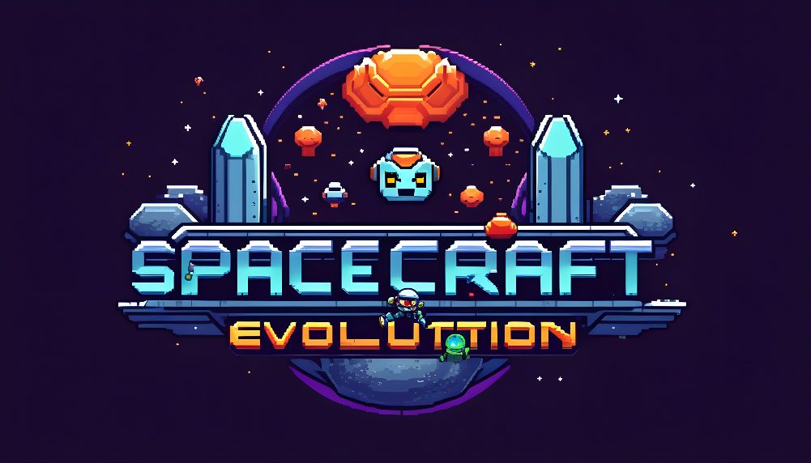
Computer science project
Joshua elliott
Spacecraft Evolution
Colchester sixth form college
2023
Analysis: 4
Introduction: 4
Features making my project amenable to solution by computational methods: 4
Stakeholders: 5
Research: 6
Existing Solutions: 6
Final Requirements: 11
Moscow Analysis: 12
Hardware and Software Requirements: 14
Design: 15
Problem Decomposition: 15
Justification of Modules: 15
Screen Designs: 18
Main Menu Screen: 18
Game Play Screen: 20
Settings Menu: 21
Upgrade Screen: 22
Death Screen 24
Internal and External Storage: 25
Server-Side Storage: 25
Client-side Storage: 26
Algorithms: 29
Multiplayer Connectivity: 29
Game state Loop: 29
Draw Background: 29
Player Update: 30
Inputs: 30
Bullet Update: 31
Checking For Collisions: 31
Screen Display: 32
Ship Upgrades: 32
Current Scores Leader board: 32
Health Bars – Client Side: 33
Developing the coded solution: 34
Technical Research: 34
Vectors and Movement: 34
Multiplayer – NodeJS, ExpressJS and SocketIO: 35
Client-side prediction/server reconciliation/ Player interpolation: 36
Sprite sheets: 37
Collision Detection: 37
Quadtrees: 38
Main Development Begins: 40
Iteration 1: File Structure Setup: 40
Iteration 2 – M1.1 – Multiplayer Connectivity: 41
Iteration 3 – M1.2 – Game State Loop: 43
Iteration 4 – M1.3 – Connecting and Disconnecting Players: 44
Iteration 5 – M2.1 – Player Movement: 46
Iteration 6 – M3 – Bullets: 53
Iteration 7 – M5 – Start Screen: 55
Iteration 8 – M2.2 – Player Movement: 59
Iteration 10 – M4 – Collisions: 60
Iteration 9 – M8 – Health System: 62
Iteration 11 – M6 – End Screen: 63
Iteration 12 – S5 – Spawn Points and Space stations: 64
Iteration 13 – M7 – Upgrades: 66
Testing to inform evaluation: 71
Alpha-Testing: 71
The following requirements were not tested as I did not attempt to implement them within my project within the given time restraints: 72
Stakeholder Testing To Inform Evaluation: 72
Evaluation: 76
Success Criteria Evaluation: 76
M1 - Multiplayer Connectivity: 76
M2 - Player Movement: 76
M3 – Bullets: 76
M4 – Collisions: 76
M5 – Start Screen: 77
M6 - End Screen: 77
M7 - Ship Upgrades: 77
M8 - Health System: 77
S1 - Name Picker: 77
S2 - Ship Select: 78
S3 - Death Statistics: 78
S4 – Resources: 78
S5 - Spawn Locations: 78
C2 - Ship colour: 79
Assessment of Usability Features: 79
Start Screen: 79
Health System: 79
Upgrades: 80
Maintenance issues: 80
Multiplayer issues: 80
Server Usage: 80
Limitations of the project: 80
Player Progress: 80
Upgrade System: 81
Potential Further Developments: 81
Mini map: 81
Account system: 81
Leader board: 81
Code: 83
Index.html: 83
Style.css: 83
Sketch.js: 86
Index.js: 108
Player.js: 115
Spacestation.js: 121
Bullet.js: 126
Game.js: 127

Analysis:

Introduction:
My project is a top-down multiplayer space shooter where a player controls a spaceship and aims to destroy their opponent’s ships while also avoiding asteroids and upgrading their ship. When they die their upgrades will be reset although there may be universal upgrades which carry into the next round. They will be able to play against an open room of enemies or in private lobbies with their friends. I would like to make this game as recently I have learnt the basics of creating a simple multiplayer game and would like to challenge myself to implement this in a more complex game.

Features making my project amenable to solution by computational methods:
The project of creating a top-down multiplayer space shooter requires the use of many examples of computational methods. In this game a player controls a spaceship and aims to destroy the opponents ship while also avoiding asteroids and upgrading their ship. They will be able to fight in an open room of online enemies or private lobbies with their friends. Below are some of the key features of my project, how they can be solved and why computational methods are an appropriate way to solve them.
The most significant feature in this project is the ability to connect with other players over a network. The players need to be able to interact and see each other’s actions in real time. This should be solvable with the use of NodeJS and libraries such as WebSockets. With the use of these technologies, I will be able to send information about each player’s game state between the clients and a server. This will mean the computation all runs on the backend allowing for a simpler front end which simply takes the game state and represents it graphically on screen.
The game will also require a collision detection system not only between the players and their bullets but also asteroids and the edge of the map. To do this, I may be able to use a library such as p5collide2D or p5play to compute the collisions between objects. If I were to use p5play then I may also be able to use this to handle physics between objects. Alternatively, I could use vectors within p5js to create my own movement script giving me full control of how the game feels to play. I could also do the same for the collision library and it would allow me to specify the algorithm to my objects within the game.
Using computational methods to create graphics for this project is appropriate as I could use a library such as p5js to dynamically create graphics and sounds based on the game state received from the server. By doing this I should be able to create a good user experience which engages the player by giving visual and auditory feedback responses to the user.
After the player’s life a leader board could show with the top ten scores which have been achieved. This can be made with the use of a database or a structured server-side file in a JSON format for example. This means I have the choice of interfacing with the scores using SQL or JavaScript depending on the choice of storage location. Each player life their score will be sent to the leader board where it will need to be sorted into place before showing the user the top of the leader board.
By using a computational approach, I will be able to scale my game very simply. I will design my game to accommodate many players at once and by using OOP (object-oriented programming) I will be able to create new instances of players, asteroids and bullets using classes. This will also make it easier to implement my upgrade system as I will be able to increment and change the properties of individual players during the game.
In conclusion, a top-down multiplayer shooter is an ideal project to solve with computational methods and approach as it requires networking for multiplayer gameplay; collision detection and physics/movements; dynamic graphic and audio experience; a high score leader board system and use of OOP to provide scalability. By using the libraries and methods I have talked about above the game will allow for multiplayer interactions and an enjoyable experience for players.

Stakeholders:
Felix Hirst will be my primary stakeholder for this project. He is a friend from my computer science class and enjoys playing multiplayer shooter games. He will be a suitable stakeholder as his passion for this genre of game will mean that I can have an inside perspective of a player’s needs.
As Felix has played many different multiplayer shooters, he knows the features which are crucial to an enjoyable user experience. This means that he will be able to recommend changes to the game, for example, to movement, balancing or any other part of the game. By Felix being a stakeholder in this project he will be able to play a game with his friends which is in his favourite genre, and it will also be designed around his preferences.
Another stakeholder in this project is Lloyd. He is a friend of many years who is a massive Science Fiction fan. Lloyd will be a suitable stakeholder as the game is going to be space themed and his knowledge surrounding other sci-fi media will not only be useful in developing the aesthetics but also within the gameplay itself.
As Lloyd is interested in the theme of this game, he will be willing to give feedback which represents other people who may be interested in playing the game after releasing due to the space theme. I have also played multiplayer space games with Lloyd in the past and they have been very enjoyable. Therefore, we will both have valuable insights into what is needed in this style of game especially when we can both playtest the game along the development process. After the completion of this project with Lloyd as a stakeholder he will have access to a multiplayer game which he will be excited to play with his friends including myself due to the nature of the game being styled within a Sci-Fi theme and that it will be designed based on some of his game testing through the development process.
In conclusion, with the inclusion of Felix and Lloyd as stakeholders I will be able to develop the game so that it appeals and caters to the needs of avid multiplayer shooter players and fans of the science fiction genre making it a successful project.

Research:

Existing Solutions:
In this section of my research, I will explore different games which are like Spacecraft Evolution either in the way that they share the same envisioned gameplay loop and or that they have a pleasing Sci-Fi theming.

Diep:
When I was tasked with thinking of game ideas my mind immediately wandered to diep.io. It is a multiplayer top-down tank shooter game, and I played the game a few years ago. While playing I enjoyed the constant progression and threat of higher levelled opponents which could appear at any moment. Therefore, I wanted to take inspiration from this game especially surrounding the gameplay loop.

Game Start:

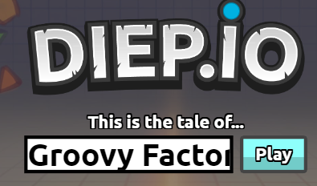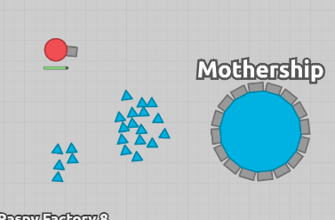
On loading into the start screen you are given a few options. First you are able to select your in-game name. This is used to show where you are currently placed on the leaderboard. I will certainly implement this feature as it means all players in the world are identifiable not only in game but also on the leaderboard. Without players being able to choose their own name they may also become less attached to the ship they are flying and be less engaged with the game.
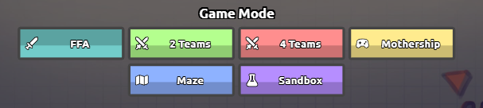
Before clicking play you are also able to choose one of 6 game modes. The default mode is a FFA (Free for all) although you could choose team modes (2, 4 or Mothership). Within the standard team modes teams can work together cooperatively to defeat the other team and get all their players to the top of the leaderboard. Whereas in Mothership, two teams work together to take down a much larger tank (mothership). Although, I like the variation of being able to switch between these modes I will create a mode most like FFA for my game. This is due to time constraints and would like to create private lobbies for friends and a cooperative mode, however, I may not be able to implement these for this project and could add them in future versions.

Account Creation:
Within Diep you can create an account using a 3rd party service called Rivet. It allows players to save their progress, create friends and choose to join games that their friends are in. Being able to create accounts could benefit Spacecraft Evolution in the same way it does Diep. It would allow for unlocks/upgrades to be stored on a server in a relational database relating player accounts to unlocks/upgrades. This means players would not lose any unlocks and can continue from where they left off. It would also mean that if I created multiple rooms or modes, you could join a game that your friends are already playing. Therefore, I would like players of Spacecraft Evolution to be able to make their own account so that they can add friends and save their progress.
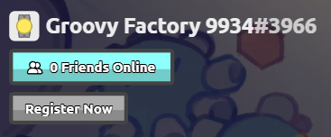

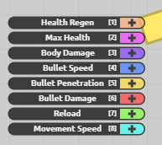
Upgrade System:
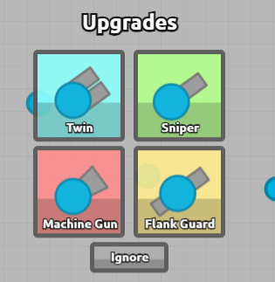
The upgrade graphic shown on the right is the most important mechanic for Diep. As your score reaches certain amounts you are given the ability to choose which attribute to upgrade. The attributes used in Diep range from health regeneration to movement speed and have a max level at level 7. These can give you a competitive advantage against your opponents and allow you to gain score faster. Another feature of Diep’s upgrade system is that at significant levels, starting at level 15, you can pick a new tank type. Examples of these tank types include twin, sniper, machine gun and flank guard and each have specific benefits and drawbacks. This engages the player and allows for more replay ability as you can play lives with different classes of tank.
I want to create an upgrade system which is similar to this for Spacecraft Evolution as it will make a more interesting experience making your ship more powerful the longer you play. I may also have several types of ships although they could be different classes you can spawn as rather than upgrades you get at significant levels like in Diep.
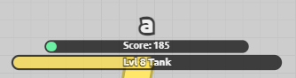

General gameplay:
While playing the game you control your tank using WASD for movement and the mouse to aim your cannon. You can then shoot with mouse click, space or E. By shooting or colliding with other shapes or players you destroy them and gain score which will level your tank up. There are three different shapes you can destroy to get score. Yellow squares have least health and therefore give the least score, red triangles are in between, and blue pentagons have the largest health pool but reward with more score. I think this may be suitable within my game by destroying asteroids to give you resources needed to upgrade your ship.
Shooting your cannon has a slight amount of knockback on your tank so you can use this to slightly increase movement speed when shooting in the opposite direction you are travelling. This is a mechanic which would be interesting to add because as the ships will be in space and so the firing of a bullet or cannon would have an opposite effect on your ship. 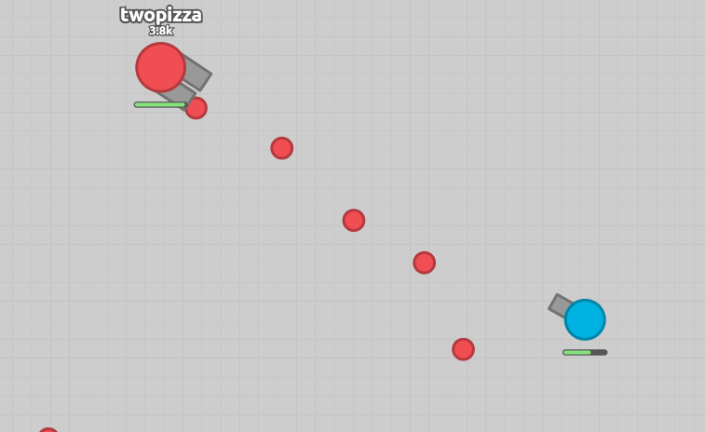 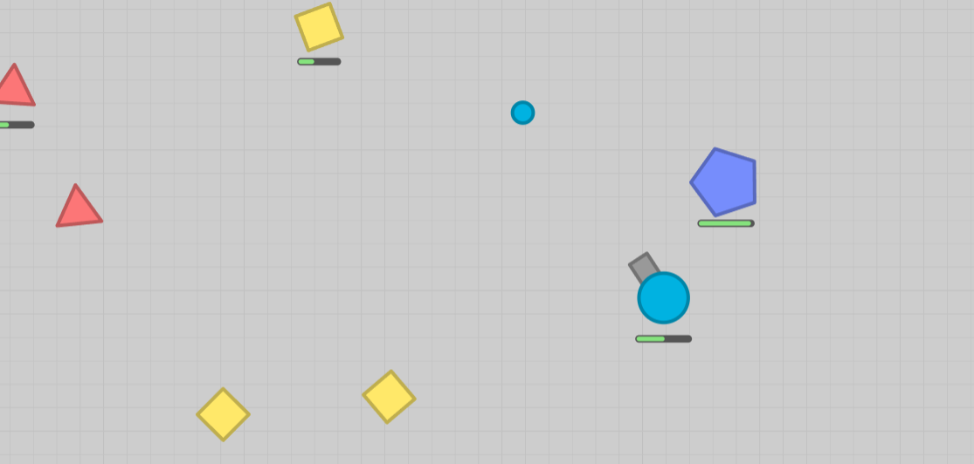

End Screen:
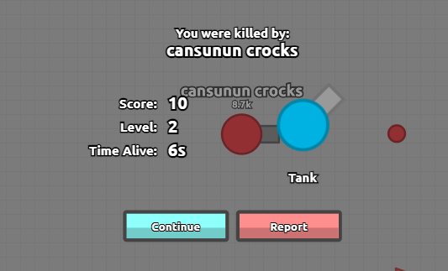
When your tank dies in Diep a death screen is shown. On this screen it shows your score, level, time survived and tank. These are a good indicator of how successful your life was and how far you progressed. It also shows who you were killed by and in the background shows them moving around until you continue. Another piece of information which could indicate a player’s success in a life is maximum and final leader board position. In my project this will be a suitable feature to add as it shows interesting statistics to the player and give a good screen to either respawn or go back to the main menu screen.

Microgravity:
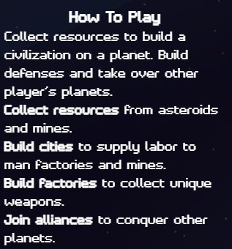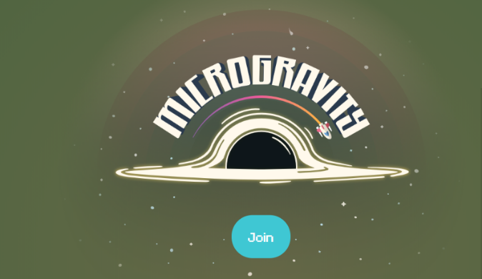
While searching for games which matched the genre and style of game of Spacecraft Evolution, I found microgravity.io.
In this game you are spawned into a galaxy with many different planets with other players in the same galaxy. The aim is to collect resources to build on planets and take over them from other players. While flying around you can destroy asteroids, fight aliens, and upgrade your ship.

Planets and resources:
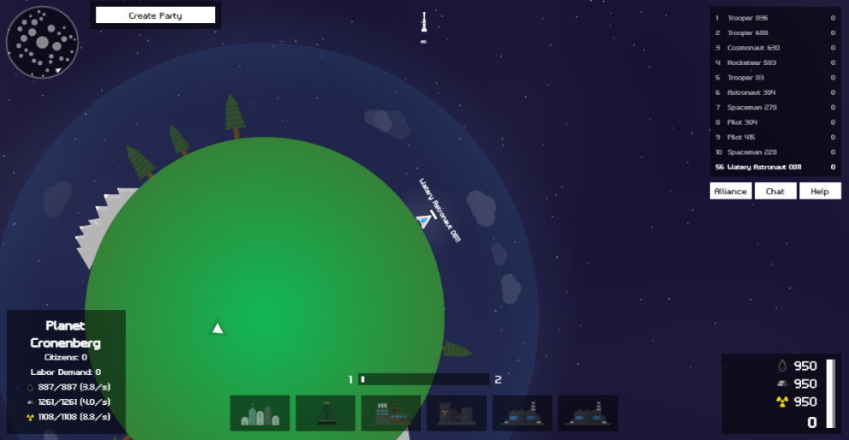
While researching this game I found the unique mechanic of landing on planets to build factories, mines, and cities interesting. When landed on the planet the player is shown in the bottom left information about the planet. This includes its name, citizens, labour demand and resource information.
You can make buildings at the cost of oil, aluminium, and uranium. They can provide labour for citizens and produce resources over time. This allows you to build more walls, mini turrets, and buildings on other planets.
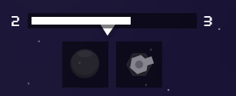

Leader board:
The leader board in Microgravity shows the top 10 players currently playing, what position they are currently in and their score. This is shown in the top right corner over a partly transparent rectangle and is useful as the player can see the leader board as well as what is underneath the leader board. Being able to see the strength of your competitors is useful so that you know who you should avoid until you are stronger and who you should be able to defeat.
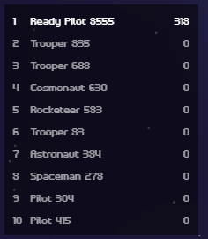

Mini map:
The mini map shows the whole map including where you are, other planets and the edge of the map. The map also shows planets a brighter white when players have built on them. This allows players to have an idea of where other players might be but not an exact location. This encourages player versus player (PvP) combat as they have specific places that they are more likely to meet around. While a map like this encourages layer interactions it also removes the feeling of endlessness from the game and therefore may impact how the player views the environment.
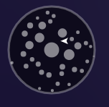

Ship Select
On the start screen of Microgravity, you can pick one of 7 different styles of spaceships. You can also pick a primary colour for your ship. The option that is selected is indicated by a blue circle and a corresponding elongated bar of colour. All the ships behave the exact same and do not give any competitive advantage, instead, this feature is implemented purely for customisation for the player. Another way this could have been used is that they are different classes with different statistics and attributes. They could also have been unlock using the in-game currencies creating a constant progression which is saved over multiple rounds. This may have kept players more engaged as they would have wanted to unlock all the ships.
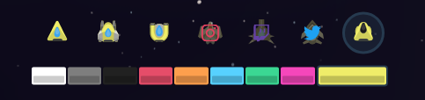

General gameplay
Besides basic movement controls with WASD the ship also has a rocket boost which can be enabled using shift and depletes the rocket’s fuel while deployed. On release of movement controls the ships continues to drift until slowing to a stop. This gives the game a feel that you are flying in a vacuum.
You can shoot with either left mouse clicks or the space bar which sends a bullet in the direction you mouse is pointing in. You can shoot buildings, walls, players, aliens and asteroids and each take several hits to fully destroy them.
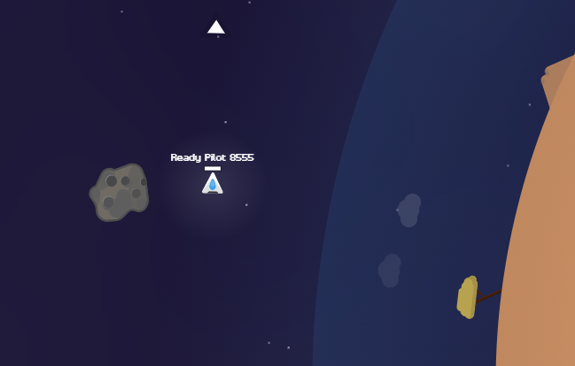
You can also collide with asteroids and other ships which causes both objects to lose speed and experience an opposite force. This causes asteroids to be quite easy to move because they are not directly pushing against you. You can land on planets and when you get within the planets field of gravity you are pulled down to the surface. This affect gets stronger the closer you get to the planet.

Final Requirements:
After researching existing solutions to creating a top-down multiplayer shooter I have created a list of potential and required features to implement into Spacecraft Evolution.
- Player movement where when controls are released the player continues to drift until eventual stop.
- Boost to increase movement speed – limited amount of fuel.
- Ability to fire bullets/missiles.
- Indicator to show direction of travel and aim.
- Firing your cannon gives your player knockback.
- Collision detection between players, bullets, enemies and other objects such as asteroids
- Health system with a bar to display the current health of the ship.
- Multiplayer connectivity to allow players to interact in game.
- Account system which allows players to save unlocks and progress.
- Ability to add friends and join their games.
- Multiple rooms – could make private rooms to play against friends.
- Start screen.
- Game modes – add team-based modes.
- Choose a name before playing.
- Select the ship type/class they will use in the game.
- Be able to select the colour or design of their ship before they play.
- Upgrade system – players can trade resources for performance upgrades.
- Unlock new types of ship.
- Build and upgrade planets/space station.
- Mini map – this could show other players, space stations, planets etc.
- Leader board – show the top ten current players in your game.
- Resources – harvest resources from asteroids and steal them from other players.
- Spawn locations – spawn on a safe planet or space station
- Death screen – show how long you lived, leader board position and score.
- AI enemies to fight/avoid.

Moscow Analysis:
Some features which I plan to implement into my game are essential to create the game which I am aiming to develop while other features are much less necessary and would be nice to add with enough spare time. I have completed a MoSCoW analysis below and the features are sorted into Must, Should Could and Won’t.
- MUST – for my project to be successful my game must include these features.
- SHOULD – should be implemented to make it a better experience and make it feel like less of a basic project.
- COULD – these features would be nice to add to the game but do not add a lot of value to the game, therefore, they should only be implemented if there is enough time to develop and test them properly.
- Won’t – I will not have enough time to code and test these features but could be added in future versions of the game.

ID | Feature | Description
MUST Criteria
M1 | Multiplayer Connectivity | At least two players need to connect in the same game and their players be able to interact. This will be done using NodeJS and SocketIO which allow the server and clients to communicate and get the necessary data about the game including other players.
M2 | Player Movement | The player should be able to move using WASD and when controls are released the player should drift to a stop to better feel like you are in space. This can be achieved with a low deceleration and an acceleration-based movement system.
M3 | Bullets | Players should be able to shoot bullets in the direction of the mouse.
M4 | Collisions | Bullets should damage players and destroy other bullets. Players should also be able to crash into each other and asteroids etc.
M5 | Start Screen | This screen should show when first loading up the game. It may have a few options to pick from and the button to start the game.
M6 | End Screen | This screen will show after you die. It might show some information and will give the prompt to either go to start screen or play again immediately.
M7 | Ship Upgrades | During the game you will be able to upgrade your ship by increasing its health/speed/damage etc.
M8 | Health System | The player should be able to view a health bar which represents the health of the ship. This should be affected by being hit by other players etc.
SHOULD Criteria
S1 | Name Picker | Before starting the game, you can pick a name that will show on the leader board and to other players which you find in the map.
S2 | Ship Select | In the game I would like to implement different ship types with different properties. This gives the player different game strategies and experiences depending on which ship type they choose.
S3 | Death Statistics | These should show on the death screen and could include stats like time lived, kills, resources gained. This will give the player an idea of how they perform game to game.
S4 | Resources | You should be able to gather resources from asteroids and other players. These could be used to upgrade your ship, unlock new ships or upgrade your space station.
S5 | Spawn Locations | Each player needs a safe zone that they can spawn in and not get spawned into existing enemy fights. They may also be able to come back to purchase upgrades.
S6 | How to Play | This should be a screen or brief tutorial explaining the aim of the game and the controls which affect the player ship.
S7 | Direction Indicator | This will act as a pointer to where the player is aiming and where the bullets that they fire will travel.
S8 | Sound effects | I should implement sound effects for collisions, HUD interaction and other in game events to give the player a more immersive experience. I could also add a soundtrack but that is of a lower priority.
S9 | Current Scores Leader board | A leader board of current players and their scores should be visible while playing to inform you of your competition and who you should avoid.
COULD Criteria
C1 | Meta Upgrades | These upgrades would carry into the next life and could include things like new ship types, better resources or general stat increases such as health or damage.
C2 | Ship colour | The player, on the start screen, would be able to change the base colour of their ship giving them more customization options and making each player look different in a match.
C3 | Boost | You might be able to gather or buy boost which will mean you can travel faster. This could be used to engage in a fight or escape if you are going to die.
C4 | Bullet Recoil | As this game is space themed, to better represent the weightlessness of space, when a player shoots a bullet, it will be moved slightly in the opposite direction.
C5 | Mini map | This would show where other players are and where you space station is located.
C6 | AI enemies | AI enemies would add a constant threat which would be harder to avoid.
C7 | Account System | This would let players save data to an account which they can log into and continue from where they left off next time they play.
WON’T Criteria
W1 | Game Modes | Other game modes could include private lobbies, 2 teams or 4 teams. These would add much more replay ability to the game but would only be beneficial with a larger player base. I won’t do this because it will take too much time and would be difficult to test and balance.
W2 | Friends | You would be able to make friends and go into games together. They could work together or fight against each other. I could also add factions/clans which could work together to take over. I will not implement this feature as there will be limited time to complete the game and there will be a limited player base to benefit from it.
W3 | Multiple Rooms | This could be in the form of different servers for various locations or simply just to prevent games becoming too cramped. Again, there will be a limited player base to benefit from it but could be added later down the road.

Hardware and Software Requirements:
I have chosen JavaScript as the main programming language that I will use to develop my game. The main reason I have done this is that I am making a web-based game which makes JS a good language as it is compatible over multiple browsers. Using a combination of HTML, CSS, JS and libraries which are supported such as p5Play I should be able to build a good-looking web-based game. I am also most familiar with this language and will be able code my solution with more success than an alternative option.
To develop the game, I will use a few libraries help me with some of the most complicated features of the game. For example, I will use Express to run the web server and SocketIO to allow the server and clients communicate. For the graphics and audio for my game I will be using P5js which is a library which makes it easy to implement these features. I am already familiar with these libraries which will allow me to focus more on development and less on relearning the basics.
Over the last couple of years, I have coded using Replit, which is an online development environment. Therefore, I will continue to use this to develop my project as I am confident and familiar in its use. I also appreciate a lot of the quality of life features it includes such as easy file management, auto format and access from any web enabled device.
I can also host this project using Replit, which is useful, as the most recent version of the game will instantly be available to the user. The drawback to this is that while developing a new feature the game will not be very playable. Although, if I break the project Replit has a feature to be able to revert to any change you made in the development process.
For this game, there will be no specific hardware requirements for development or for use. This is because I will use my personal and college computer to develop it and it can be played on almost any device on the web. The game will also not be very demanding although a better internet connection will better you experience as it is a multiplayer game.

Design:

Problem Decomposition:
Decomposition is the process of breaking down a problem into smaller and more manageable parts. This is useful for development as you can think about all the separate smaller problems individually and integrate them later down the line. For this reason, I have split my project into many different modules which can all be developed separately but when put all together will make up the entire game.
This should be beneficial to the development process as while creating one of these modules I should be able to test each of them and find bugs within each feature meaning that when I compiled them all together there will be less unintended behaviours and problems to fix.
By doing this it will also make it easier to track my progress through the development of the project as I will be able to mark of which parts I have completed and know what is still left to develop.

Justification of Modules:

Client:
I have split my project into two main modules, the server side and the client side. The client side is responsible for receiving information from the server and displaying it to the user alongside menus and UI to be able to navigate the game. It should also receive user inputs of the keyboard and mouse and send the information to the server.

UI:
This module includes all the HUD (Heads-up display) for the player including health bars, current players leader board and resources. Included within this module there is also a scrolling background which will move in all 4 directions and should match the players acceleration and velocity to immerse the player so that they feel that they are moving through space. Health bars should show the health of each player clearly either in a long bar or in equally divided sections. There may also be other effects of having low health such as visual or physical damage to your ship or potentially a red glow to the screen. I also plan to show what resources the player has collected and therefore has to spend while upgrading as well as a leader board to show all the current players and their current score/level in an order which is easy to read while remaining focussed on the game. This module is particularly important and it puts all the information the player needs to play on the screen in an easy format to read/interact with to create a good user experience.

Menus and Screens:
Within my project there will be many different menus. The first will be the main menu screen, where obviously a good visual appearance but also there are many other functions of the page other than looking nice such as settings options and customisations to the game. For example, before the player can think about starting the game, they need to select a name, ship and potentially colour using buttons and an input field. This should be easy, intuitive and when finally selected should send a signal to the server to store this data in the player object. This will allow the user to feel like they are playing as a version of themselves and be attached to the success of their ship. Another screen within my game is the main gameplay screen. This will include all the UI mentioned above for the gameplay and display the game state given by the server. After the player has died, an end screen will be shown. This should compile all the relevant statistics and progress made from the players round and show clearly how they did. There should also be a prompt to play again or return to the main menu screen. Another part of this problem is the options menu. This could include volume sliders for sounds and music as well as potentially other options as well. These should affect the game as the settings are being changed. This is important because it allows the player to see how the changes, which they are making, could affect them during the game.

Display Game:
I need to be able take the game state received from the server and show all the objects stored within such as players, asteroids and bullets. Without this part of the game the player would not be able to see any of the most important parts of the game including their own ship.

Manage Inputs:
It is important that the client can recognise player inputs of the mouse and keyboard and communicate with the server to say what player pressed what key. This will enable the player to click on the screen to fire a bullet and move using WASD keyboard presses. There may also be an immediate impact for the user on an input, for example, on a menu.

Server:
The other main section of my project is the server side. This module should be able to calculate all states of all the objects within the game as well as handling any messages received from the client. It should then be able to have a main loop in which at the end it sends the current game state to the client.

Main Loop:
The main loop of the game is extremely important because it determines how often the game state is updated. A higher rate will mean less input delay, whereas a lower rate could be nicer to the server and client's computer. This should be responsible for checking for collisions, deaths and update all the other objects in the game.

Receive Clients Messages:
The server needs to be able to receive messages from the client and update the game state based on those messages. For example, if the player inputs to move using WASD then the server should update the player’s velocity and position according to that input. These messages may also occur when a player (dis)connects, presses the mouse or presses any other keys on the keyboard.

Asteroids:
Asteroids should be a consistent source of resources for players which will allow them to upgrade their ship even when there are few other players to fight. They spawn randomly and drift across the map. They may damage player ships if they collide but when destroyed with player’s bullets, they should break down into different resources for the player to collect.

Players:
The players are a very important part of the game and one of things that this module includes is calculating the collisions of the players into all other objects. The collisions should be consistent and predictable, so that players can try to dodge enemy bullets to the best of their ability. Players also need to spawn in a location where there a few other players, so they don’t get killed immediately. This is important because players should not be discouraged from continuing to play the game but should have a chance to upgrade and go on to fight players who have been playing for longer.

Space Station:
Space Stations are in some ways unique to this game and so this module is important to get right. There will likely be between 2 and 8 space stations on the map and they will primarily act as a spawn point for players. Players should be able to dock back onto the spaceship later in their ship’s life and apply upgrades to the ship using the various materials they have collected through the round. Without this section of the game, the game would be like most other top-down shooters and may not appeal to as many players in the same way.

Game State:
This module is how all the information about the game is stored in one place. This will allow the client to draw all the relevant sprites as well as collisions between different types of objects to be calculated. This is possible as all the information for the current game state is stored in this object meaning that information can be compared and used to calculate and it should be the same as the player can see.

Screen Designs:

Main Menu Screen:
This is the main menu for my game and will be the first thing the player sees when they enter the game. It should allow the player to select their ship, colour and name before playing the game. Besides a title, space background and player button this screen is made up of 3 main sections.
Within the section labelled as one, the player should be able to type in a name which will then be shown on leader boards and to identify who is what ship in a match. It should be a simple input box which allows for the player to put in their name before selecting other options for the customisation of their ship.
The second section is for the ship type selection. There are currently four ships in the game and therefore need to update the design in the next iteration to have 4 ships to choose from. The one that is selected should be visibly changed to show it has been clicked. In the example below the border of the box has been thickened.
Finally, the third section is the colour selection buttons. I plan to start with 4 colours and each of the ships will have a variant using that colour. Therefore, I need to update the design with the specific colours and only four boxes to select. As with the ship selection buttons there should also be a change in the box when it is clicked so it shows that it has been selected. The ships above should also change colour so that the player can see what the ship will look like in game.
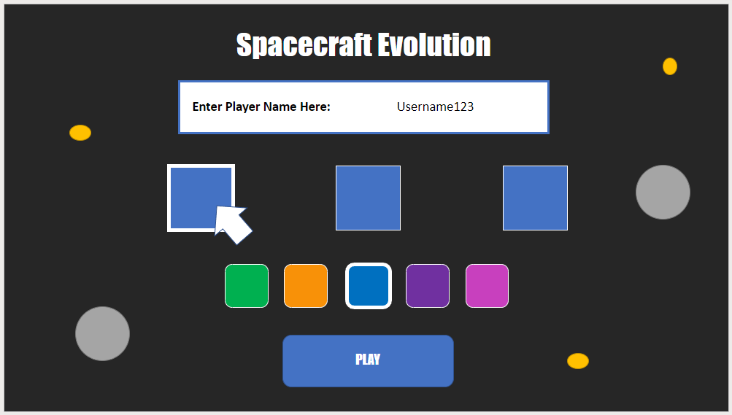
1
2
3

Feedback on Design:
Besides the design changes that were planned since the initial design of this screen, there are only a couple of changes which came about due to discussions with my stakeholders. For example, the settings button is now in the top right corner so that players can adjust their settings while not in the game. This means that players do not need to do it while playing the game itself and can set it up before going into a match. The new colours for the ships I have chosen are also detailed below.
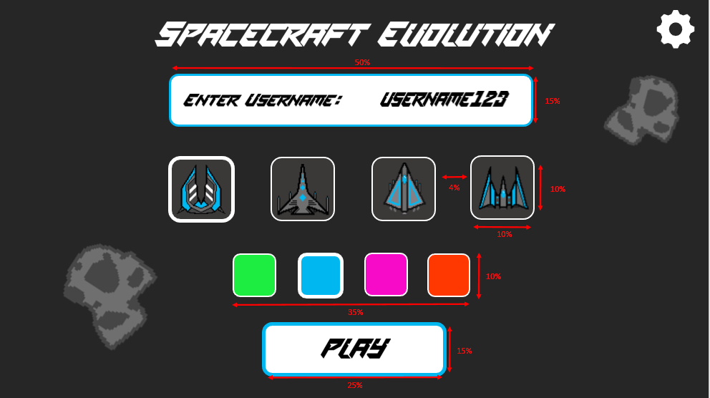
green: 1ded40
blue: 00B7ef
pink: f70ac8
orange: ff3700

Game Play Screen:
The current players leader board is shown on this screen labelled as section 1. It should show the top 5 players and will also show your position on the leader board. The leader board should actively change as people live longer and upgrade their ships. Section two of this screen is the player. The player is centred in the middle of the screen and will be able to fire bullets towards asteroids as seen in the image below but also other players. A health bar can also be seen in the bottom left corner labelled section 3. It will be fixed in the bottom left corner and as the player is damaged will decrease in fullness. Other than the settings button in the top right the only other main section of this game play screen is the resources in the bottom right corner labelled as section 4. This will show how much of each material the player has to spend on upgrades for their ship. There will be 3 types of materials for the three different types of upgrades.
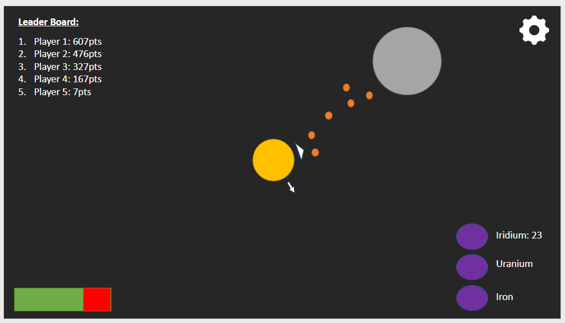
1
2
4
3

Feedback on Design:
I discussed this page with Felix as he of my stakeholders has played a lot of multiplayer shooters and he emphasised that an easier to read leader board would be beneficial. Due to this I removed the numbers showing the order as this is assumed as the top being higher scoring. I have also highlighted the users score in their chosen colour to make it easy to identify what your own score is relative to other players. A similar conversation was had surrounding the resources. There was no benefit to having the name of the material next to the icon and number, therefore, I simplified the design to just have the icon and number to represent how many of that material the player has.
Lloyd had some interesting inspiration as to the design of the HUD in the game shown by the health bar and leader board. He thought it would be cool to design the HUD as if it were a fighter pilots heads up display in their cockpit. This lends itself very nicely to the brighter and almost neon colours I have chosen for the ships so depending on the colour chosen the HUD will be that colour. I also simplified the health bar to two colours to fit this theme.

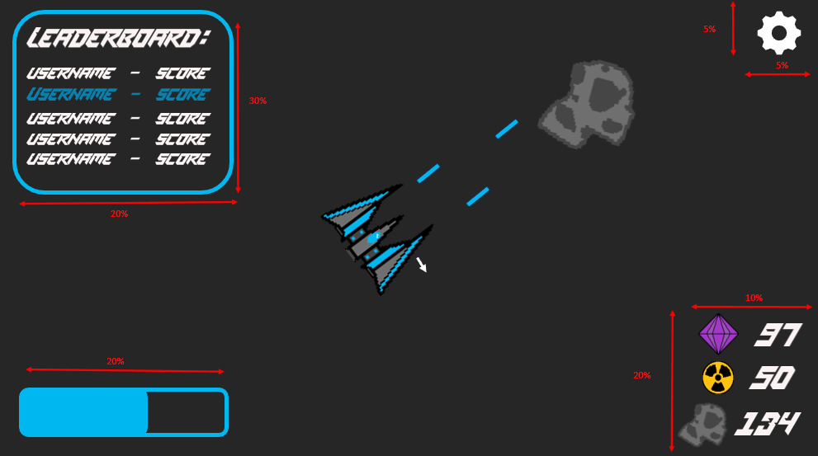

Settings Menu:
The settings screen should overlay the current screen and act as a modal/dialog box. It should be accessible by a settings icon (cog) from the top right of the screen on both the gameplay and main menu screens. I currently only have volume controls in this screen but after conversation with my stakeholder I may understand some other settings which are important to be able to change to suit each player’s personal preferences. With reference to the volume sliders, I think that the boxes to manually type a specific volume value may be unnecessary and may make the UI look better without them with only a minor impact on the user. These sliders should update the volume as they change, so players can hear how loud it will be once they leave the screen.

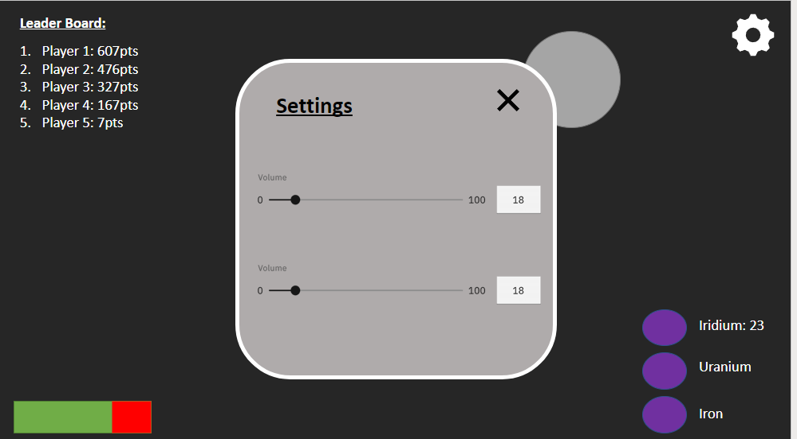

Feedback on Design:
As this screen is simple, there was very little feedback from my stakeholders although I had a conversation with my friends about this screen and as a result decided to change the sliders to be larger but without the number to change to a specific percentage volume. This lets the user listen to the sound to decide where to put it on the slider which will be mapped to change the volume relative to how far along the slider it is. The only other change to this is the font which has been changed globally.

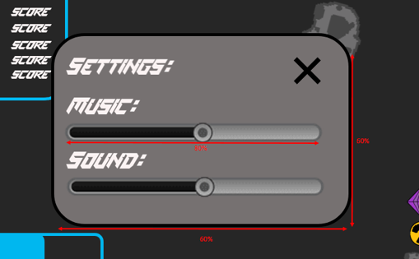

Upgrade Screen:
This screen will be accessible from the space station once the player has docked. In the top left there is an overview of each of the materials the player can gather and how much they have of each. Each of these materials can be used for a different category of upgrades. These categories are weapon, ship and ability upgrades. Each of these sections have an indicator to show which material it is that can be spent and well as a list of all the upgrades that the player can do. List items are accompanied by an upgrade button and a number to show how much the upgrade is going to cost.
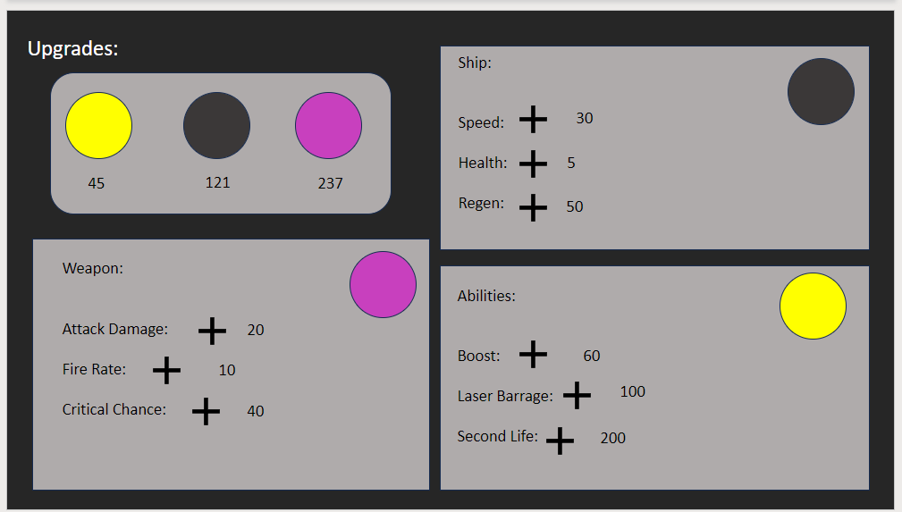

Feedback on Design:
I discussed this screen with my stakeholders and they agreed that This page would look better if I made the upgrade button look like a button. I also added text to show what level the stat is currently at so players know what needs upgrading more and players can prioritise upgrades based on their preferences. Based on Lloyds suggestion relating to fighter jet HUD I attempted to follow the theme on this page but struggled. In the end, I added a solid background to the upgrade panels.

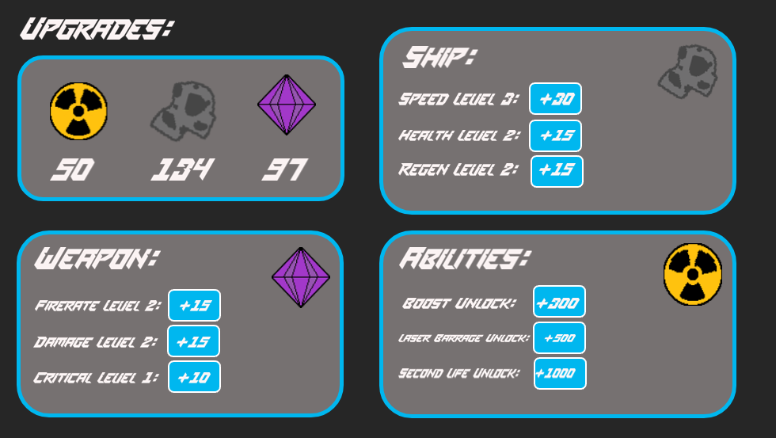

Death Screen
The death screen will show when the player dies. It should alert the player that they have died as well as giving them navigation options. At the bottom of the page the option is given as to whether the player would like to play again or return to the main menu. In the centre of the screen a few stats including the number of kills and upgrades applied.

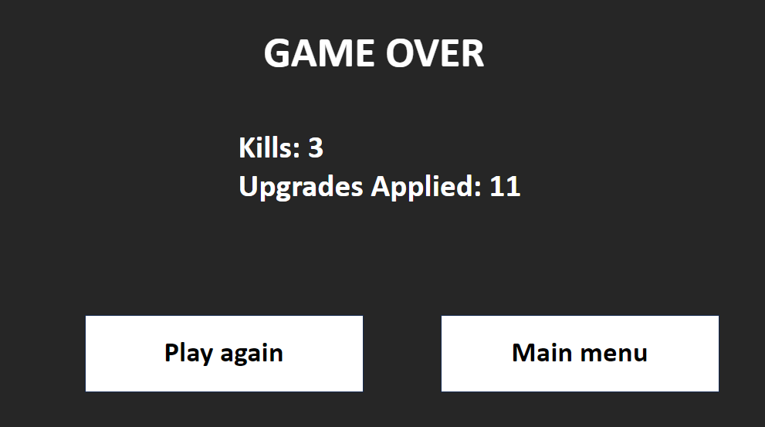

Feedback on design:
After a discussion with my stakeholder Lloyd surrounding the aesthetics and science fiction theming of this screen, we decided that an image of the ship in which you achieved this would add to the context of the statistics shown on the left. Not only that but I have also changed the font of all text in the game to SPACE MISSION to give the whole project a more futuristic and science fiction feeling.
I also discussed this screen with my primary stakeholder Felix. He thought that another helpful measure of success for this game would be the time the player has survived. Therefore, I have added this to the list of statistics on the left of the screen.
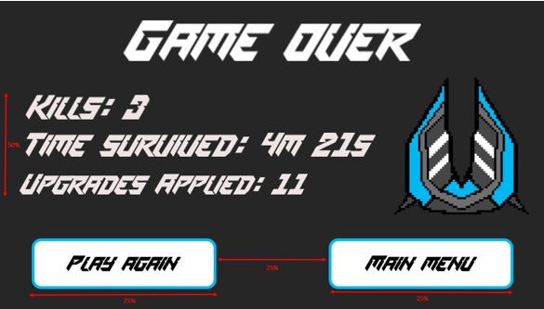

Internal and External Storage:

Server-Side Storage:
In the simplest form of my game there will be very little stored on the server. However, in later versions if I have time to develop some of my COULDS (from my MoSCoW analysis) I may introduce a database table.
Field | Datatype | Comments
Player Id | Integer | Id to make each player that has played the game unique so that their progress can be accessed from the server.
Player Name | String | The name that the player has given themselves in the game.
Unlock State | String | This is a JSON formatted string which stores which ships have been unlocked and what upgrades each of them has.

As all the calculations are being done on the server, I will also need all the objects which are present on the client-side. However, with the difference that the classes on the server-side will not include the draw method as there is no ability or requirement for the server to produce any graphical output.
In the server-side code I will need a global variable for the current game state. This may be update in the main loop and sent to the client after each iteration of the loop. For the server itself to function I will also need some variables to store the express app and socket connection.

Client-side Storage:
The client-side storage is used for taking the data from the server and displaying it the player. This is done by using an object-oriented design and so majority of classes which will be required are detailed below.

Player Class:

Attributes:
Position | The position of the player as a vector. This determines where the player is drawn as well as how the scrolling background is drawn.
Velocity | This is the speed (in a direction) of the player stored as a vector and determines how quickly the player’s position changes.
Max Velocity | This is the maximum speed the player can reach. Every time the speed changes this attribute is needed to check the player is not moving too fast.
Acceleration | As this game is in space the player needs to build up speed over time and also lose it slowly over time. This gives a better replication of zero gravity than instantly moving in the direction the player inputs.
Health | This is an integer that represents the current health of the player. When decreased to zero the player dies.
Max Health | The initial health of the player in the beginning of the player’s life. If they manage to regenerate health after taking damage later in the game then their health cannot increase beyond this number.
Socket Id | This is the socket identification number of the player’s connection to the server. This number will not be the same if you reload the page.
Player Id | This number is made unique for each player and could be used to access information about a player’s previous play session such as upgrades unlocked.
Colour | This is the colour of the player’s ship and therefore UI accent colour.
Damage | This is the amount of damage the player does by hitting another object with the ship itself.

Methods:
Constructor | This is run on initialisation and sets all the attributes to what they should be.
Update | This is called each iteration of the main loop and may check for collisions or death. It would also change the player’s position by the player’s velocity and handle other movement script.
Move | This would be called when the player inputs a key (in WASD) and would increase the velocity of the player.
Death | Called when the player dies, this could prompt the game over screen and set the player status to dead so it does not interfere with the game still going on.
Respawn | This will respawn the player at their space station and reset their health to maximum health.
Draw | This should show the player on screen at the position of the map which they are located.
The player class will be responsible for keeping track of and calculating the players movement and health of the player.

Bullet Class:
This class will be used to store and calculate all the information about each individual bullet.

Attributes:
Player | This is the player object which fired the bullet and can be used to determine certain attributes of the bullet including damage and colour.
Colour | This is the colour of the bullet as this will be the same colour as the player’s colour.
Speed | This is the speed the bullet travels in whatever direction is fired in.
Position | Stored as a vector this is the position of the bullet and where it will be drawn on the screen.
Velocity | This is the speed in a direction of the bullet and will also be stored as a vector.
Size | This is the size of the bullet and will be used for collisions and for the display of the bullet.
Damage | The amount of damage the bullet should do to other objects when they collide is stored in this variable.

Methods:
Constructor | This is called on the fire of a bullet and the player object which fired it will be parsed into this function. This will then be used to determine all the initial attributes of the bullet.
Update | The update method will move the bullet using the velocity of the bullet.
Draw | This will be used to draw the bullet on the player’s screen when it should be visible to the player.

Asteroid Class:

Attributes:
Position | The location of the asteroid on the map stored as a vector.
Velocity | This is the speed in a direction of the asteroids also stored as a vector.
Health | This is the amount of hit points the asteroids have until it is destroyed.
Rotation | This is a random amount of rotation to vary the appearance of the asteroids.
Width | The width in pixels of the asteroid.
Height | The height in pixels of the asteroid.

Methods:
Update | This runs each iteration of the main loop and updates the position of the asteroid based on the velocity as well as checking for collisions.
Draw | This will draw the asteroid on the player screen.
Constructor | On creation of the asteroid they position, velocity and rotation should be randomized.
On Explosion | This is called when the health of the asteroid is reduced to 0. This should leave materials for players to collect.
This class will be used to store and calculate all the information about each individual asteroid.

Game Class:
An instance of this class will be sent to the client so an updated version of the game state can be drawn on the client screen.

Attributes:
Players | This will store all the players in the game with a corresponding socket id.
Player amount | This is the current number of online players.
Bullets | This stores all bullet objects which have been fired but not been collided with yet.
Size | This is a vector which stores the size of the game screen.

Methods:
Change in player amount | This is called when there is a change in the player of players. This may remove a space station which is no longer needed as well as update the player amount attribute.

Space Station Class:
The space station class will be instantiated each time

Attributes:
Player | This is the player that is assigned to the space station. They will spawn here and can return throughout the game to upgrade their ship.
Is Docked | This is a Boolean variable to show if the player is docked in their space station or not.
Width | This is the width of the space station and will be used for collisions and the display of the object.
Height | This is the height of the space station and will be used for collisions and the display of the object.
Position | Stored as a vector this will be where the space station will be shown on the screen.

Methods:
On Dock | This may move the player to specific location, so it looks like they have docked on the space station.
Draw | This method will be used to show the space station on the player’s screen.
Show Upgrade Screen | When the player presses a specific button an upgrade screen should show to allow the player to upgrade their ship.
Constructor | This will be called on the creation of a space station object when a new player is created.
An instance of this class will be created when a space station is required as a spawn location for a player.

Global Variables:
Other than the classes required for the game the client will also need a few global variables.
Socket | This will store the connection to the server and allow the client to communicate with the server.
Height | This is a global variable which will relate to the client’s window height.
Width | This is a global variable which will relate to the client’s window width.
Game | This will store the current game state and will be received from the server each time the server’s main loop is completed.

Algorithms:

Multiplayer Connectivity:
This algorithm should create a simple connection between the client and server and should be run when the code is first run. Before this algorithm is run the ExpressJS and Socket IO libraries should be installed.
- Require ExpressJS and Socket IO
  - Create express app
  - Set server up to listen for communication from clients
  - Use this to create a socket connection
To test this, I should check that the server can successfully receive a message from the client and vice versa.

Game state Loop:
This algorithm will create a loop which is run once for each frame and at the end sends the most recent game state to the client.
- On the server-side create a loop which runs as often as a new frame will be shown.
  - Update the game state and all objects in it.
  - Send the game state to the client.
- On the client-side listen for the game state.
  - Update the global game state of the client with the new data.
  - Be able to draw the game using this game state until a new one is received.
This should be tested by sending a game state to the client and being able to read from it on the client-side. This can be a basic template until the game is built out further.

Draw Background:
This function is called every frame on the client side and should draw the background for the game.
- Calculate the relative position of the centre image compared to (0,0).
- Draw one image being the image starting at the coordinates calculated above.
- Then draw the 8 surrounding images so that when the player moves it moves into space with a background and not empty space.
This can be tested by moving in all directions at least 2 widths of the screen.
- If you can always see a background and there are no other weird affects then the algorithm should be working correctly.

Player Update:
This is function should be called time the main loop is run while the player is alive and is responsible for some of the player movement and checking for death. This is algorithm is a method within the player class.
- Check if the player’s velocity is greater than deceleration
  - Decrease the player’s velocity by the deceleration value.
- Check if player’s velocity is less than deceleration
  - Set player velocity to 0
- Increment the x and y position of the player by the velocity
- Check if player health is 0 or lower
  - Call the player death function
To test this, I will run the algorithm a few times and test it will different data including different directions of movement, positions and health values:
- The player’s position should correctly be incremented by the player’s velocity.
- After the player moves in a specific direction and release their input it should slow to a stop and their velocity should be (0,0).
- Only if the player health value is 0 or lower the player attribute alive should be set to false.

Inputs:

Mouse Click:
This function will be called on the server every time a player clicks their mouse.
Parameters: mouse x, mouse y, player Id
- Check if the mouse position is on any buttons or inputs.
  - If they are, then press button or focus on input.
- Find the difference between the player x and player y.
- Store the normalised gradient as a vector.
- Create a new instance of the bullet class parsing in the player and direction of the bullet (vector calculated above).

Keyboard Press:
This function will be called when the player types on their keyboard.
Parameters: Key Pressed, Player Id
- Check if the key is in WASD
  - Call player movement method parsing in the key
- Check for other key functions such as if the player is dead and still on the game play screen and key if ENTER
  - Return them to the main menu.
These algorithms should be tested using a lot of different inputs and combinations of inputs in various screen within the game.
- Pressing WASD should move the player in the corresponding direction
- Clicking the mouse should fire a bullet in the direction of the mouse from the player unless the mouse click is on a button or the player is dead.

Bullet Update:
This function should be called every frame that the bullet exists and is responsible for the movement and out of bounds check. This algorithm sits within the bullet class.
- Updates x and y position by adding the normalised vector of the bullets direction and multiplying it by the bullet speed.
- Check if the bullet is still within the range of the map.
  - Return Boolean of bulletInRange as true if it is within thew constraints of the map and false otherwise.
  - This will then cause the bullet to be removed from the array.
To test this, I will run this code with lots of different data including, mouse position, background position and bullet positions.
- I should go to near the edge of the map and fire a bullet into the border and I should see that it is removed. This should be tested for all places that it could go out of bounds.
- Also, in all positions on the map when the player fires the bullet the bullet should go through the location of the mouse unless the player is moving and then it should correctly adjust for the movement of the player.

Checking For Collisions:
This algorithm checks whether a player is currently colliding with any other objects such as bullets, asteroids or other players.
- Loop through each of the players
  - Check if the current player is colliding with each of the players excluding itself
    - Take damage – remove health based on how much damage should have been done
    - Check if the player is dead
      - Set player to dead
  - Check if current player is colliding with any bullets excluding their own.
    - Take damage – remove health based on how much damage should have been done
    - Remove Bullet
    - Check if the player is dead
      - Set player to dead
This can be tested by forcing a bullet and player to collide with another player and checking that the correct amount damage has been taken and object which need to be removed have been removed. This would include bullets which have collided as well as dead players. The same can be tested for asteroids and other objects when they are implemented.

Screen Display:
This algorithm should work out which screen should be displayed and then display the screen that should be shown.
Parameters: Player Object.
- Check if the player is alive.
  - Show game player screen.
    - Show scrolling background.
    - Show leader board.
    - Show health bars.
    - Show other objects such as players, bullets or asteroids.
- Check if the player is dead.
  - Show death screen.
    - Show background and game over text.
    - Get player life statistics such as time played, kills and score.
    - Show Buttons for play again and back to menu.
- Check if player is neither dead nor alive.
  - Show start screen
    - Show Background and title
    - Show Name input
    - Show colour and ship select
    - Show play button
To effectively test this algorithm, I should force the player to be alive, dead and neither in turn and check all the correct screens are shown in each instance.

Ship Upgrades:
This algorithm should be called when a player upgrades their ship while docked in their space station. It should then upgrade the relevant attribute of the player/player’s ship.
Parameters: Upgrade type, how much to upgrade by.
- When an upgrade is clicked.
- Subtract resources used from player resource counts.
- Increase the attribute which has been upgraded.
- Update the upgrade screen.
This can be tested by after upgrading the ship checking that the upgrades have been successful.
- Attribute of player/player ship has been updated.
- Resources have been taken from player pool.
- The upgrade screen has been updated to show the new price and upgrade available.

Current Scores Leader board:

Update leader board on death:
This algorithm should send a player’s score and name to the leader board and store this information each iteration of the main loop.
Parameters: Players
- Get each score, name and socket id.
- Format the data so that it can easily be read from a JSON file.
- Append the data into the file.
To test this a player should get a score and then check in the file to see if their current score is up to date.

Draw leader board:
To draw the leader board every frame the current top five scores need to be fetched from the leader board.
Parameters: Player object
- Get the data from the JSON file.
- Find the top five scores and sort them.
- Draw the names and scores in order.
- Put the user’s name and score at the relative position.
To test this, I should get a few players with varying scores and check that each of the leader boards accurately reflect the scores of the game.

Health Bars – Client Side:
This algorithm will take the player health and draw a health bar for the player so they can see how much damage they have taken.
Parameters: Player Object
- Draw the outline for total/max health.
- Map the health to the number of pixels out of the total width of the health bar.
- Fill in the health bar with a bar of width the same as what was just worked out.
Testing this algorithm would be done by taking damage from another player and checking to see the that the health bar goes down proportionately. Another easy way to check that this is working, is by shooting the player the number of times that it would take for them to die. At this point the health bar should be empty.

Developing the coded solution:

Technical Research:
Before starting to develop my project, I am going to complete some technical research to help me find the right technologies to create each feature and test how they work so I better understand each one when I come to developing the game.

Vectors and Movement:
Within my project I need to create movement systems for both my players and bullets. I have used vectors briefly in the past so know that they will be a useful tool to achieve this. While researching the best way to implement them I found this site: cratecode.com/info/p5js-vectors. It explains what they are and the syntax to use them within the P5js library which I am familiar with. First you define your vectors using createVector() and the initial values of them. Then later in your code you can refer to each value by vectorName.x or .y. This is a much simpler solution rather than having many variables for each vector.
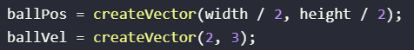
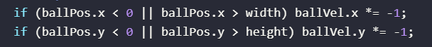
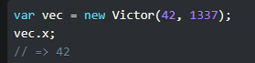
However, as I will be calculating my movement in my NodeJS file I will not be able to use the P5js library. This leaves me with the option of just using variables such as ObjectPosX or using a NodeJS library such as victorjs.org. To test how I could use Victor, I implemented it into my movement prototype script for my game and I now have a prototype of an acceleration-based movement system for the game. It being based on acceleration means that the ship will feel like it is drifting in space and make it a bit harder to change direction.
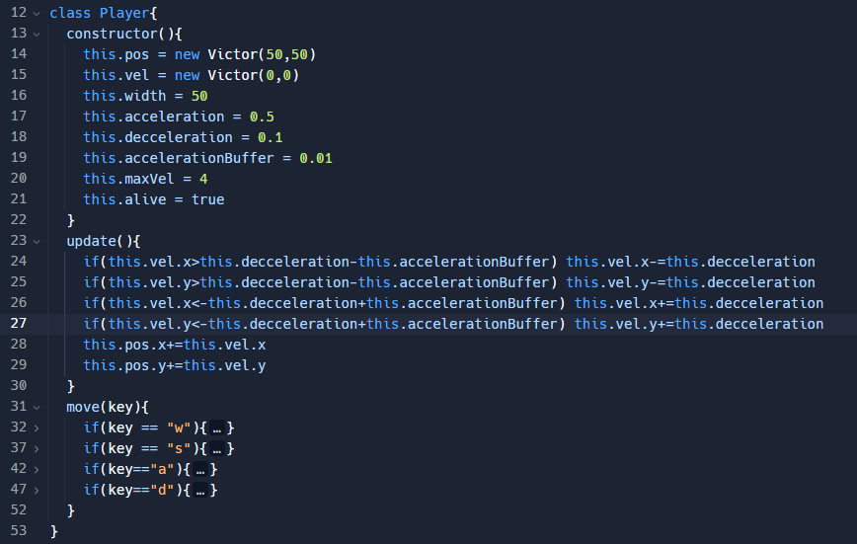
During this process I came across a few bugs within my code, one of which being that instead of the player coming to a full stop it continued but very slowly. To fix this, I added the acceleration Buffer which means the velocity gets fully reduced to zero by the deceleration over time and therefore fixed this bug.

Multiplayer – NodeJS, ExpressJS and SocketIO:
To create a multiplayer game with JavaScript (JS) you need to be able to write JS on the server-side. NodeJS is a back-end runtime environment that allows you to do this. I spent some time researching how this is used and found a Developer.mozilla.org Page which introduces NodeJS and Express which was very useful in understanding can be used to make a multiplayer application.
Web Frameworks are tools/structures which help develop web applications and most web applications will use one. Different frameworks support different languages including JS (express), Python (Django or Flask) and Ruby (Rails). To make development easier, I am going to use ExpressJS as it supports the language that I am most confident in and is the most popular framework to be used in conjunction with node. ExpressJS is a minimalist framework but there are many libraries written to help handle cookies, sessions, user logins etc. This may be useful if I create a user login system or want to collect/store play session data.
I have also discovered a library called socket.io which allows for simple bi-directional communication between clients and the server. This makes sending data between the server and client quite simple. I have used this library in the past both to make a basic messaging system but also a multiplayer snake game. Below is a screenshot showing how to send and receive messages to and from the server.
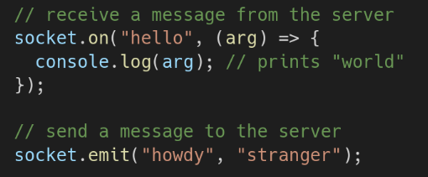

Client-side prediction/server reconciliation/ Player interpolation:
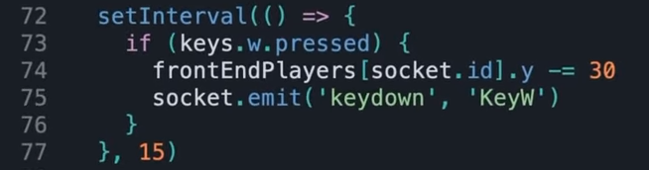
While I was researching different ways that I could make my multiplayer shooter, I found a tutorial series by Chris Courses. Within his 5th video in the series, he uses the above methods to reduce input delay and create a smoothly running game. The first of these, client-side prediction, is where, as the player inputs to move, the player is immediately moved to the new position at the same time the movement is sent to the server. This will reduce the input delay by not having to wait for the movement to be sent to the server and then back again to the client.
This code is from the tutorial and checks every 15ms if the W key is being pressed. If it is, it moves the player on the front end and then emits the movement to the server.
Server Reconciliation is another way to make movement feel more instant and to stop your player position being out of sync compared to where it should be after your inputs. This is done being indexing every input that you send to the server as well as keeping a local copy. Then each update on the client-side you check what was the last input which was processed on the server and loop through the inputs which have not yet been applied.
These will be important features to add to my game as it gives the feeling to the player that movement is very responsive and they feel in full control. However, if the server is experiencing latency, then this will only mask it on the players screen and not on opponent’s screen.
This is where player interpolation can be used to smooth the movement of other players in screen. Within this tutorial Chris used the GSAP library to interpolate the player coordinates which allows him to specify the duration and type of “ease” which the interpolation should use. This means that when latency is higher than usual the gaps between server updates are predicted and smoothed so that the players do not suddenly jump to their final position.
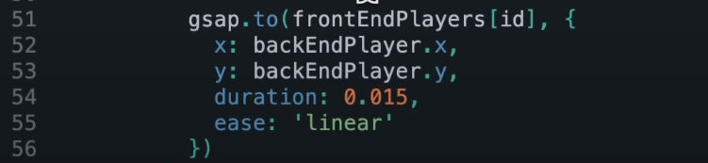
By implementing these features into my game, it will be much easier to play and interact with others as their position will be more accurate and inputs will affect the players positions instantaneously. This will lead to a much more enjoyable game where no players should have a competitive advantage due to latency.

Sprite sheets:
To display animated sprites, instead of having many different files for each stage of animation, a better solution is to have one file (a sprite sheet). This is one file with all the images within an animation and some include all images for an object with multiple animations.
Within p5js, the image method has optional parameters which allow you to show a smaller section of an image which lends itself perfectly to interface with a sprite sheet. With this method you would need to loop through the columns/rows in the sheet where each next frame is.
Another way of doing this with p5js is by initially looping through the sprite sheet to create an array of images. You can then more easily loop through the array and this could make the draw/main loop of the game more readable and efficient.
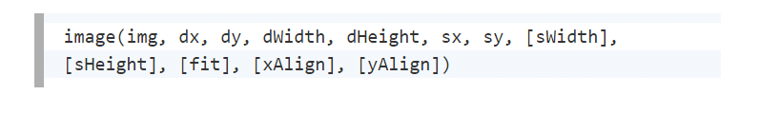
The Coding Train has a tutorial on animated sprites where he stores all the information about the frames (position, width, etc.) in a JSON file which he references while looping through the sprite sheet. This would be beneficial if the sprite sheet is not perfectly formatted or if you have a smaller loop of frames, however, if it is a large grid of frames then it will be better to loop through using coordinates.

Collision Detection:
Here I have developed a simple collision detection function which checks if any bullets have collided with the player. I was helped to create this by looking at the source code of the p5Collide2d library especially as this was my first time doing this for circles rather than a rectangular objects. Doing this was not too challenging, despite having a few bugs where collisions were not detected at first, before I realised the cause of these being a misspelling of some variable names.
I then integrated this into my main loop which is currently sending the game state to the client 50 times per seconds.
However, the way I have implemented it here is very performance heavy as you are looping through all players and all bullets many times a second. Due to this I will research ways that I can only loop through some bullets etc. I think that quadtrees may be one way to solve this problem.
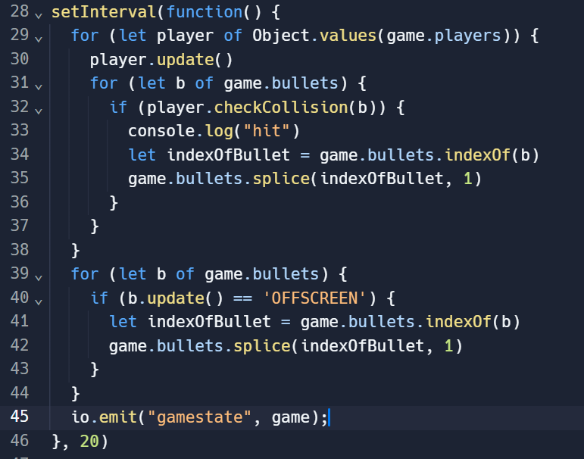
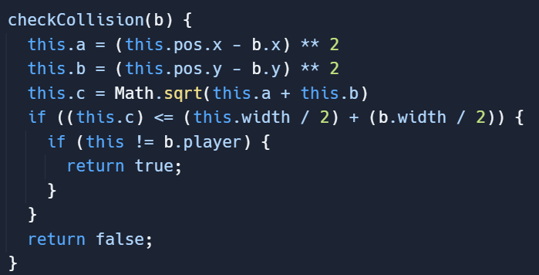

I also looped through all the bullets to check if they have gone off the screen. In time, this will change to the entire playing space or a certain distance from all players. If they have left the specified area the bullet is spliced from the array. This will help to reduce performance issues with bullets of the map constantly moving when they are no longer needed.

Quadtrees:
A quadtree is a specific type of k-tree which are all tree-based data structures. A quadtree specifically is where you split each node of the tree into four children often displayed visually as a quadrant.
While researching this data structure I found a few videos including one by MrHeyheyhey27 which clearly explained the basic concept of a quadtree, how they are made up and how they can be much more easily modified than other structures.
I also found a video by the Coding Train details how to create one in JavaScript which could be useful if I decide to implement this into my project. The main ways this could be useful within my game is storing the positions of bullets and asteroids relative to the player. By doing this I could significantly reduce the number of loops and conditionals I would need to work out if these objects are colliding.
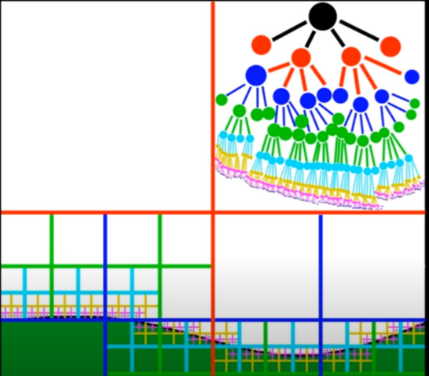

Main Development Begins:

Iteration 1: File Structure Setup:

File Structure:
To setup the basic file structure for this project I created the below four files. This index.js file is the main file which will be run on the server-side, will run the main loop and listen for messages from the client. Then within the public folder, which is the client-side of the project. I created index.html, sketch.js and style.css files.
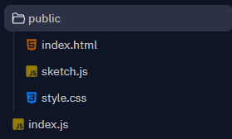

HTML file:
The HTML file sets up the page that the game will be run on as well as including libraries which I will need such as P5js and SocketIO. It also links any JavaScript files which I have written using the script tag. At the moment It only does this for sketch.js.
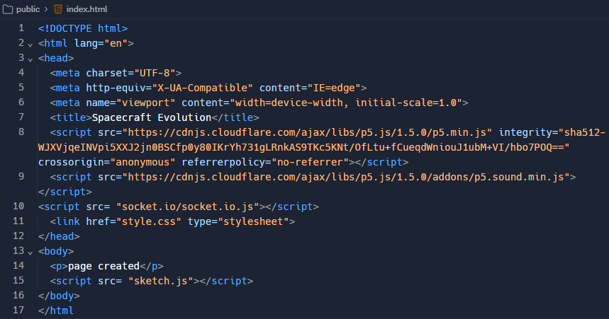

Testing:
I tested that this page setup was working by opening the page in Microsoft Edge and the title as well as body content was displayed correctly and without error.
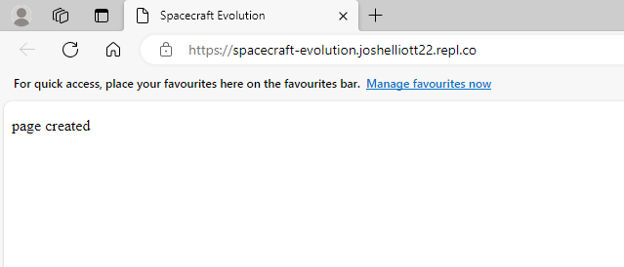

Iteration 2 – M1.1 – Multiplayer Connectivity:

Server-side:
Multiplayer connectivity is a crucial part of my game and it needs to allow for quick communication between the client and server. On the server-side index.js file, I have made use of the libraries which I researched, ExpressJS and SocketIO which I have included on line 2 and 3. In the IDE I am using, Replit, these libraries are recognised and so install on the server when the code is run for the first time. If this was not the case, I could install them using the CLI (command line interface).
On line 6 I create an express app and store it in a global variable named app so this can be accessed throughout the file. I also store a global constant for the port that the app will be using on line 7.
I then specify that the app should be using the public folder before setting the app to listen for client messages from the specified Port. Then on line 16 I use this ‘server’ to create a socket connection which allows me to use the SocketIO library to communicate between the client and server-side.

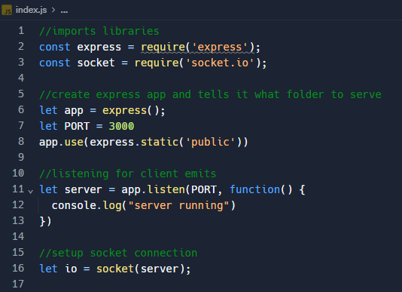

Client Side:
The client-side implementation of multiplayer is much simpler. I have created a global variable named socket to store the connection between the client and server. I can then later in the code use this to send and receive messages from the client.
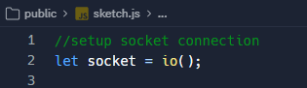

Testing:
I have tested this by sending messages both from the server to the client and from the client to the server. This has been done using the socket and io.on() methods which listen to the server and client respectively for messages as well as the socket and io .emit() methods which send a message to the server and client respectively.
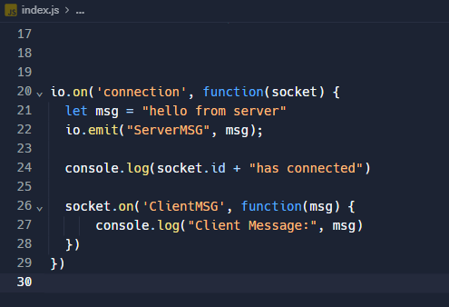
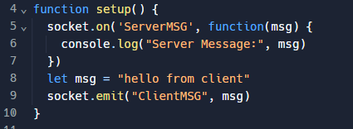
Below the messages which were expected to be received have been logged in the console successfully showing this algorithm is working.
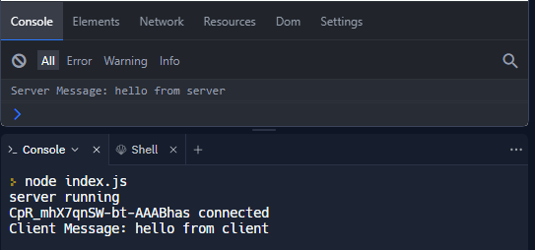

Iteration 3 – M1.2 – Game State Loop:

Overview:
So that within my game’s draw loop I can draw all the players, asteroids and other objects I need the client to be able to access the most up to date version of the game. Therefore, the server will send the client the most up to date version of the game 50 times per seconds (every 20ms) to match the frame rate of 50 that the client will run at.

Server-side Implementation:
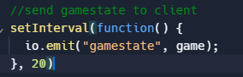
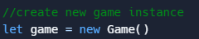
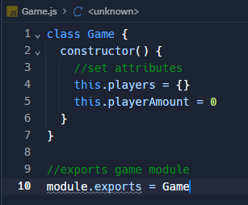
First, I created a basic game object template with a few required attributes within its own Game.js file. I export this as a module so that this can be used in the index.js file where I make a new instance of the Game class as well as set up a loop where this global game variable is sent to the client every 20 milliseconds. To do this I required the Game.js file at the top of the file in the same way I included the ExpressJS and SocketIO libraries.

Client-side Implementation:
On the client side I am using the socket .on() method to listen for the gamestate event. When the event does occur then the data parsed to the client is used to update the global variable in sketch.js to the most recent version of the game.
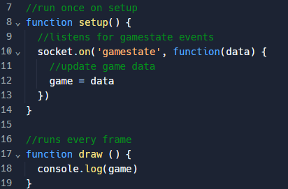

Testing:
I tested this was working by logging the value of the game in the draw loop which is run every frame and it showed an object which accurately represents the game object which was created on the server.
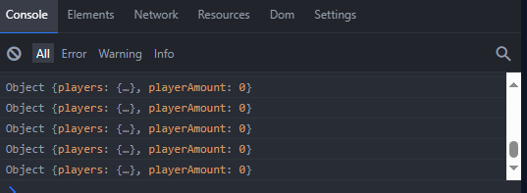

Iteration 4 – M1.3 – Connecting and Disconnecting Players:

Player class:
The first stage of development required to allow players to connect and disconnect was to create a player class. Within its own Player.js file I used my class diagram for the player and I created a basic version of the player class. For the position (pos) attribute for the player I have used a vector making use of Victor.js which I research earlier in the project. I then exported the class as a module so it could be used in other files.
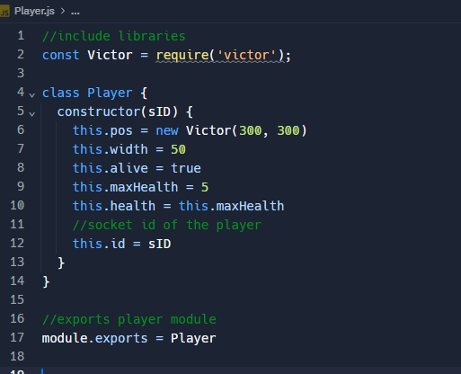

Connection and disconnect Events:
I then wrote the code below in index.js. This listens for the ‘connection’ and ‘disconnect’ events and when they are heard the functions are run.
When the a user connects on line 30 a new player is added to the players object with their socket id as the key. This will allow for easy access to the player from the server and client-side. Line 31: I have also incremented the player count to match the number of players that are in the game.
When the user disconnects from the server their player is removed from players using the corresponding socket id and the player amount is decremented so it remains accurate to the amount of player in the game.
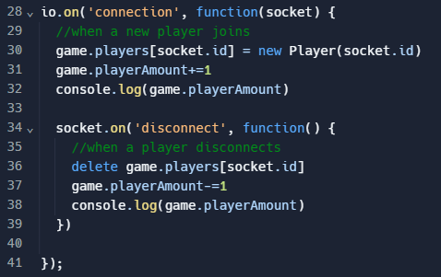

Testing:

Setup up and draw function changes:
To effectively test the functionality of this feature, I have created the canvas which the game will be shown on, given it a simple background (grey coloured) and set the frame rate to 50 frames a second, although this was not required at this stage.
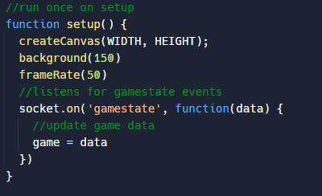
As a result of the set-up function above the draw loop is run 50 times per second. After checking that the game and some players exist, I loop through the players object and draw a circle at their position and of their width. This will allow me to see the players on the screen and will aid me in testing this feature.
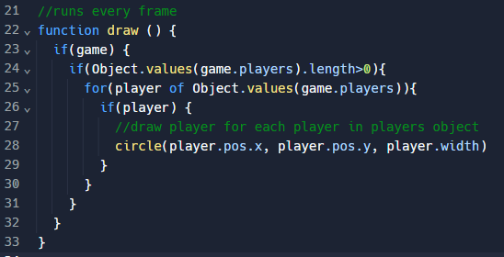

Test Results:
For the test, I joined with 3 players shown by the first ‘1 2 3’ which where output in the console and I could see that these players were shown at the correct location of (300,300) pixels. I then disconnected 2 of the players and the player amount, which is being logged to the console on but the connection and disconnection of players, showed to be 2 then 1 as expected.
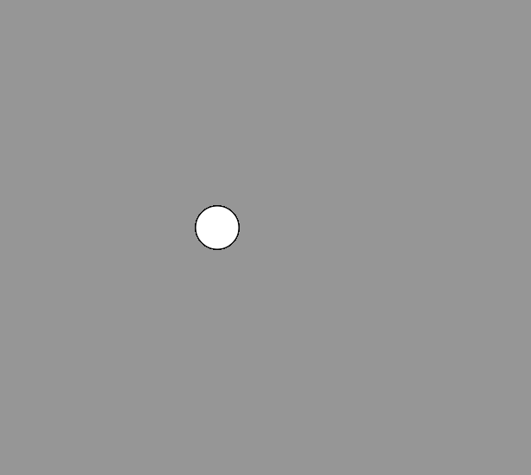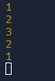

Iteration 5 – M2.1 – Player Movement:

Keyboard Inputs:

Client-side checks:
The player should be able to move using WASD and therefore I wrote a movement function in script.js which is called every frame to check if any of these buttons are pressed. If they are being pressed, then a move event is sent to the server parsing through the key that was pressed as well as the socket id of the player.
While making this change, I also decided to add a key released function which send the server a keyRelease event when the user releases a key. While this will not be directly used for movement it will be required for other aspects of the game.
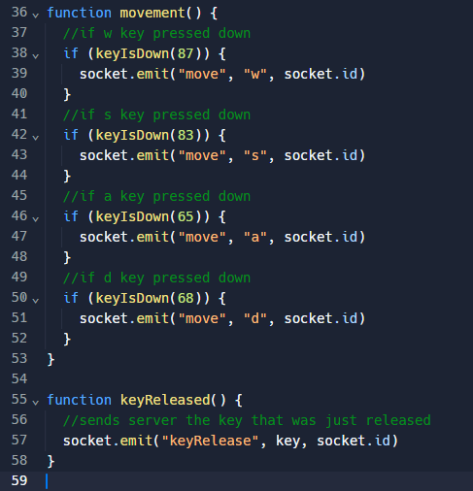
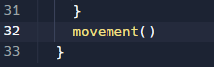

Testing:
To test the keyboard inputs, I logged each of the keys received by the server to the console and got each of the 4 inputs successfully when I pressed them.
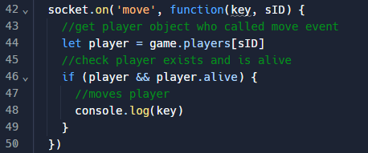
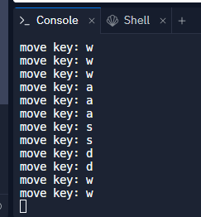

On Events:
I then updated the socket. on () to call the player move method when a move event is heard from the client. Before this method is called, I also checked if the player exists and is alive. I complete the same checks before logging to the console, although I have not implemented the function after a specific key is released.
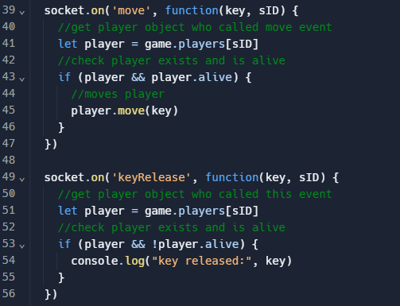

Movement:
During the development of the movement of the player I ran into a large number of bugs. Before I ran into any problems, first I added velocity, acceleration and maximum speed attributes to the player class. This will enable me to tweak the feel of the movement by changing the acceleration and max speed values. I may also need to add a separate deceleration value in order to slow down at a different rate to speeding up. This could enable me to better make the ships feel like they are in space.
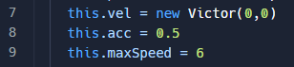
I then wrote the player move function where the outer most if statements make sure the acceleration which the player has inputted for does not make the player exceed the maximum speed. If it does it does not increase the player’s speed. Nested within these checks for both y velocity and x velocity respectively, there is a check for which of the keys which relate to that axis were pressed. For the direction which should be affected the velocity is increased by the acceleration.
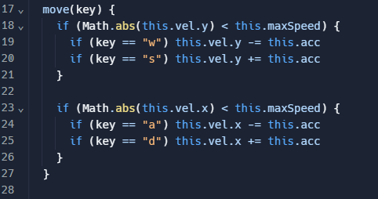
In the player update method, I have set the position to increase by the velocity of the player. This moves the player and will allow me to see the effect of the changing velocity values.
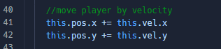
The two lines of code below are responsible for decaying the velocity of the player, so they do not drift endlessly through the map. I check if the velocity is positive and if it is then I subtract the acceleration from their velocity. However, if the velocity is negative then the acceleration is added.
In doing this I encountered some issues such as players drifting slowly across the screen and also infinity speeding up off the screen. After rereading the code, I realised that I had the minus and addition signs in the wrong place so updated it to the code above. However, the drifting was a more challenging issue. To investigate this issue, I logged the x and y velocity to the console and discovered that the velocities were alternating between zero and the acceleration. This was because I was not accounting for the fact the velocity could neither be positive or negative as in being 0. Therefore, to fix this I had to check if the value was zero before the other checks so that it was not being accelerated for no reason.
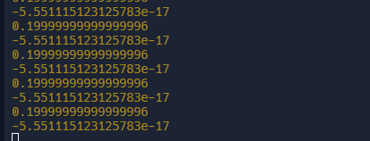
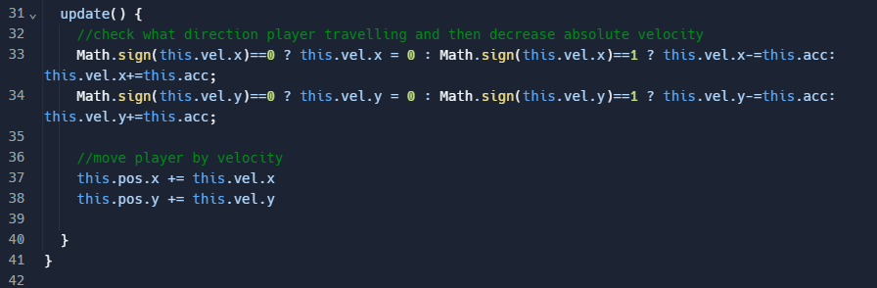
I tested that this was working by logging to console the x and y velocities to show that when the player stopped moving the velocity fell to 0 and stayed there until further input. They did and the player was also visibly not moving at the same time.
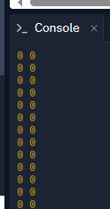
I then decided to implement a separate variable for deceleration as mentioned previously to give the player a better feel as if they are in space. To do this I gave the player a deceleration attribute and replaced the acceleration with it within the velocity decay code. I also needed to give it a minimum speed equal to the acceleration of the player to avoid having the same drifting problem as before.
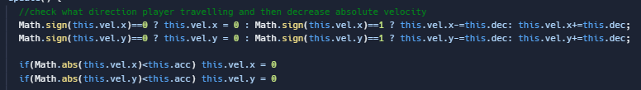
To test that I had not recreated my previous error I completed the same test of logging the x and y velocities and checking that they all return to zero.


Scrolling Background:
This section aims to get the player to stay in the middle of the screen and have a background to move to help make the ships look like they are moving through space.
First, I created some global variables in sketch.js for the background image, position and velocity it needs to move. I also preload the image which I have put in an image folder within the assets folder. This means that the app knows what the background is as soon as it loads and there is not gap waiting for the file to be found. In the setup function I set the position and velocity of the background to 0 to get the variable ready to be updated by the server’s player values.
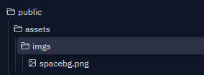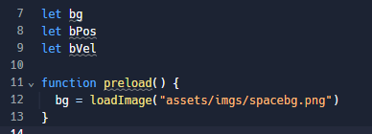
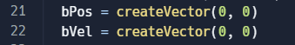
I then wrote the draw background function this takes the background position and mods it so that it is within the player's view. This determines the main image which will be shown for the background, however, another 8 images are drawn around the main one so there are no gaps or issues when moving quickly or off the initially viewable area.

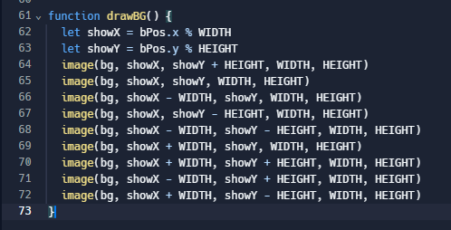
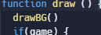
After calling this drawBG function in the draw loop I quickly tested that the initial image was being drawn which it was although as I had not set the background position to update, I could not test the other 8 images.
To maintain the player in the middle of the screen I translated the coordinates to set the player position to be half of the width and height of the screen.
I also update the background velocity with the players velocity and update the background position each frame to be affected by that velocity.
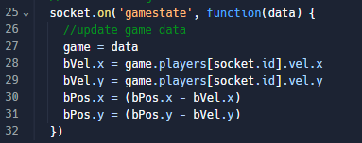

Testing:
When I first tested this feature when travelling in an upwards and right direction, I found that the background took a while to be drawn. I then found that one of the images I was drawing was the same as another. I then updated the drawBG function to fix this issue.
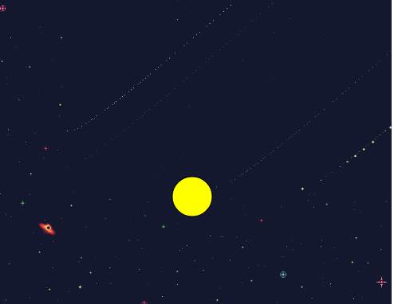
I had no other issues when testing this feature although I do want to find an alternative background with an aspect ratio which I can fix the game at.
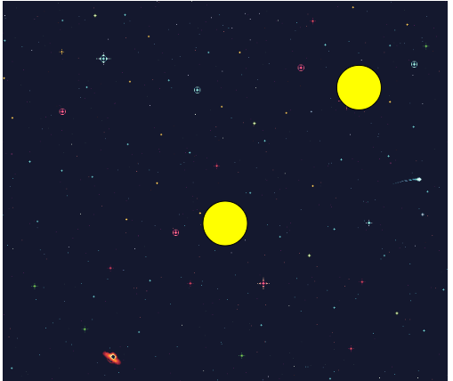

Iteration 6 – M3 – Bullets:
This iteration aims to add bullets which the player can shoot in any direction around the player. My first change to do this was creating a bullet class. This will have various attributes most of which will be assigned values by the player and vector parameters which are parsed into the constructor.
The update method is responsible for changing the position of the bullet based on the velocity. This will also return “OFFSCREEN” if the bullet goes a width or height away from the player. Later I may change this to when bullets hit the edge of the map.
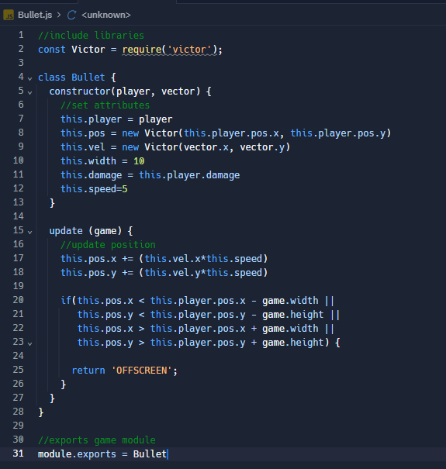
On the client side when the mouse is pressed an event is sent to the server. This sends the mouse position, background position and the socket id of the player.
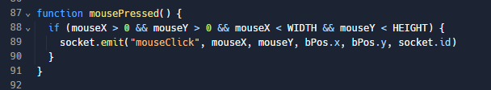
Then when this event is received on the server the direction that the bullet should travel in is calculated. I have had many issues with this due to overcomplicating the issue. As first as shown below I was attempting to find the world mouse position by using the background position. This meant that despite clicking in one direction the bullets would travel in another one. I was able to fix this by using the centre of the screen and the actual value for the mouse x and y. To make this feel better I also need to play around with how the player velocity may affect the bullets. I then used this to create the bullet by parsing in the player and mouse direction.
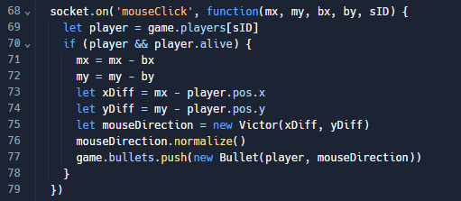
The way I was able to make the mouseDirection calculation work is shown below.
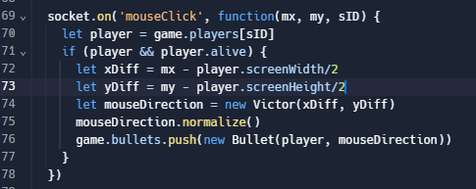
The bullets are looped through on the client and simply drawn as red circles for now. Later I may add a sprite in to represent the bullets.
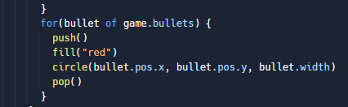

Testing:
To test this, I moved around the map and tested that no matter where I was the bullets always were shot toward my cursor. The bullets also came from the centre of the ship

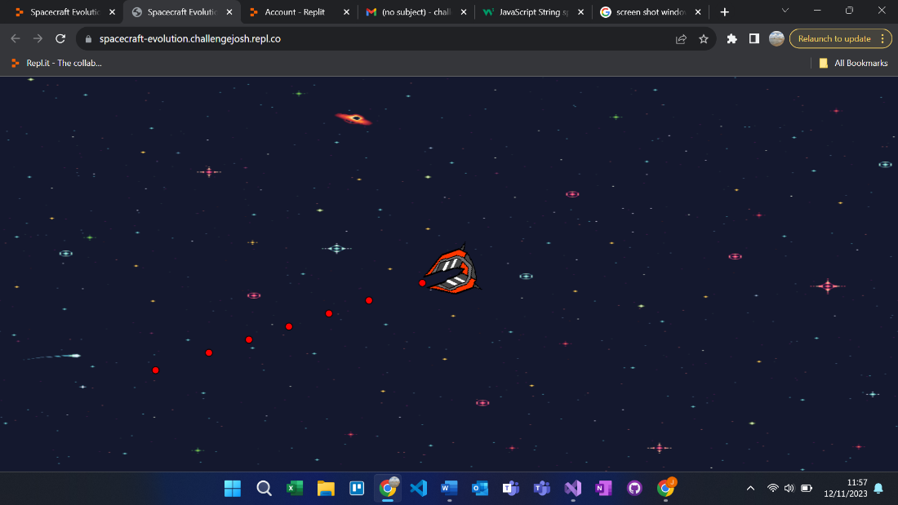

Iteration 7 – M5 – Start Screen:
I decided to start developing the start screen by first writing an if statement to determine what screen should currently being shown. This was quite easy as the player object already has an attribute called alive. This happens to be true when on the game screen, false on the end screen and not set (null) on the start screen. I then separated the code for drawing these screens into functions.
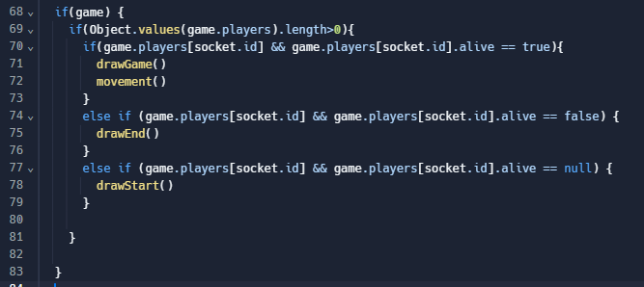
Firstly, I drew the title at the top middle of the screen using the font I found during the design stage. I had to calculate how long the text was to be able do this.
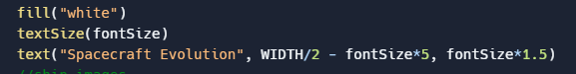
The next step was creating a function that creates all the inputs (and buttons) needed to show the start screen and is called in the setup function. I first created the play button with the test “Play” within it. I gave this a couple of classes to help me style it and all the other buttons I make later down the line. I then positioned it centred at the bottom of the screen. I also gave a function to be called when pressed. This will be used to start the game for the player.
I then completed a similar process for all the coloured buttons except for giving them a colourButtonPressed method to be called on the any of the colour buttons being pressed.
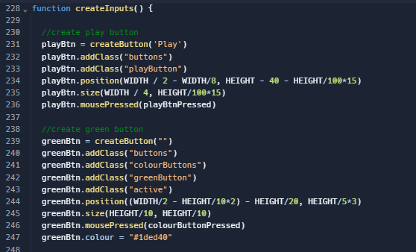
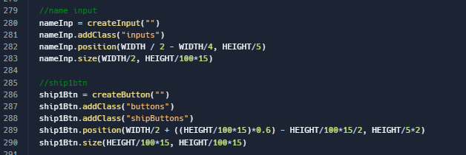
I then created the input to take the player’s name and I positioned it centred just below the player. I also gave it a function which is called each time something is being typed. The nameInput function gives the player name a maximum character count of 12.
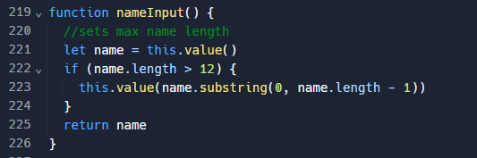
I also made the 4 ship buttons which will allow the player to select which ship to use. I positioned them between the input and colour buttons and made them larger than the colour buttons. However, I then attempted to draw the ship sprite on top but realised this was not possible. Therefore, I put these ship sprites as the buttons themselves and styled the buttons to match the other buttons.
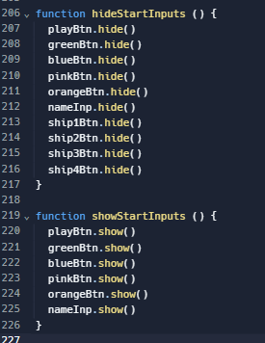

I decided that I wanted the borders off all the inputs and buttons should change when a different colour is selected to that colour. I gave each of the colour buttons a custom attribute of colour and set them to the hex codes of the colour. Then in the draw start screen function I set the border colour of each of the inputs and buttons to the colour of the active element.
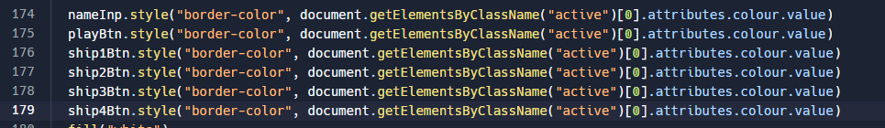
The function below first checks that the player has entered a name and sets the player button to active. I then get the colour which the player has selected so that I can send the colour, name and socket id to the server so the player can be spawned.
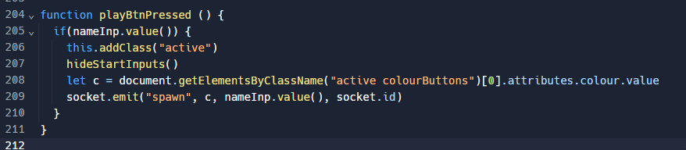
I then needed to style the inputs and buttons on the start screen so wrote some CSS. I started by getting the font which I am using for the project and named the font-family spaceFont. I then removed the padding and margin on the page allowing the game to go to the edge of the screen.
I then made a class to apply to all buttons. This gave them all a white solid border and centred any text within them. This gave the basis to allow active buttons’ borders to be made thicker when the button is pressed.
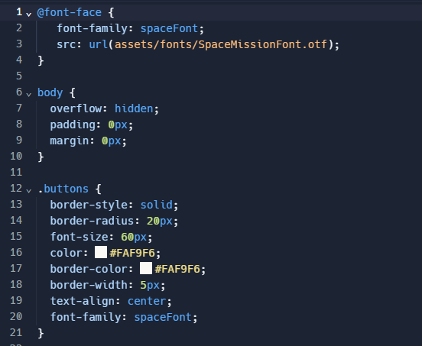
I then made an individual class for each coloured button to give them their specific colouration. I used the hex codes which have been used in making the ship sprites for my game.
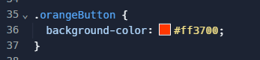
The active class increases the border width to 10 pixels of the selected buttons and inputs. I also gave all the ship buttons a grey background as well as creating the styling for all inputs such as the name input on the start screen. Main style changes in this class are using the Space Mission font, centring the text and choosing a default font size.
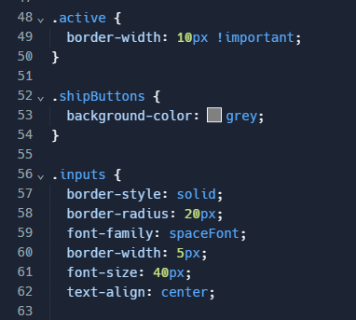

Testing:
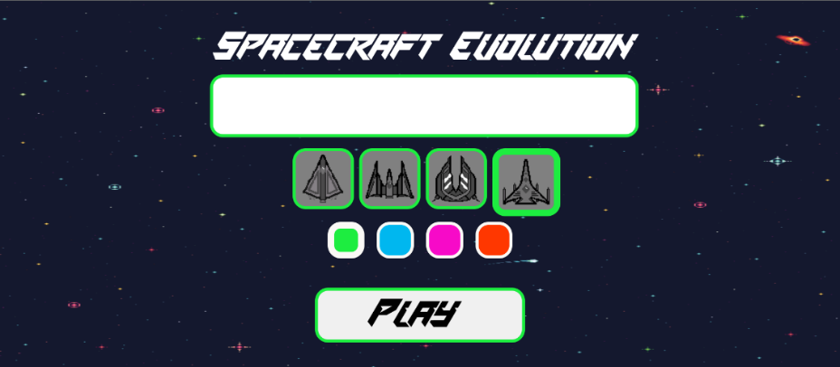
Testing this section consists of checking that each of the buttons acts as expected. For example, checking that the coloured buttons and ship selection buttons cause the correct ship to be shown for the player. It should also not let a player spawn before choosing a name.
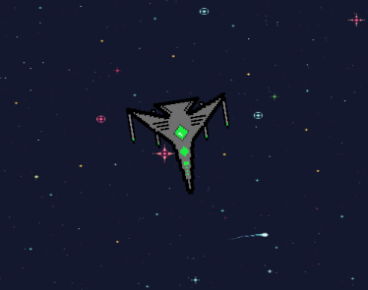

Iteration 8 – M2.2 – Player Movement:
In this iteration I am revisiting player movement at I have decided I want the player ship to face towards the cursor and the direction bullets can be shot in. Firstly, I created this calculate angle function on the client and called it every time the mouse was moved. This sent the mouse position to the server with the players socket id.
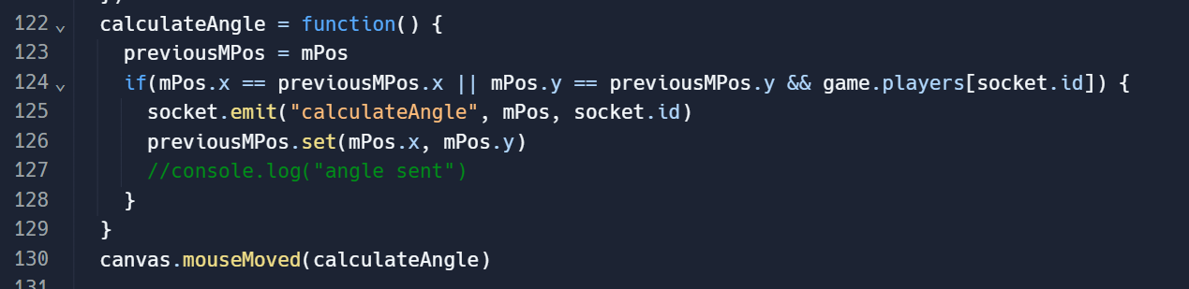
On the server, I use the Math.atan2 method to find the angle between the cursor and the middle of the player’s screen. At first, I found it hard to visualise how this should work so for a while I was using the player’s position instead of the screen size. This gave me angles which I could tell were incorrect as the player was rotating in the wrong direction and off the screen. This angle was stored in the player object in an attribute named “angle”.
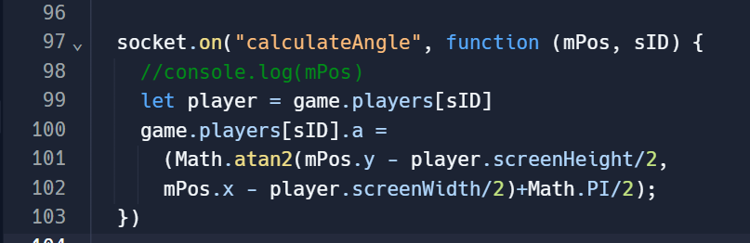
To show the player, on the client, I translated by the player position to put the origin in the middle of the screen. This is because to place the player in the middle of the screen initially I was translating by half the screen size minus player position. I then rotated the player by player.angle before drawing the image at negative the player width. At first, I had issues with the ship rotating around the centre and not on the centre point. This was because the ship was being rotated around the top left corner of the sprite and not the centre.
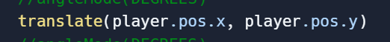
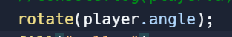

Testing:
I was able to simply test this by flying around and ensuring that the ship always faced my cursor and matched the direction bullets would fire when the mouse was pressed.
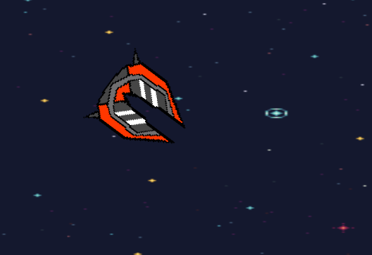

Iteration 10 – M4 – Collisions:
Iteration 8 will implement collision detection and handling between players and between players and bullets. I firstly created a method within the player class which will check if the player is colliding with any other circular object. It will return true if the player is colliding with the other object (“o”).
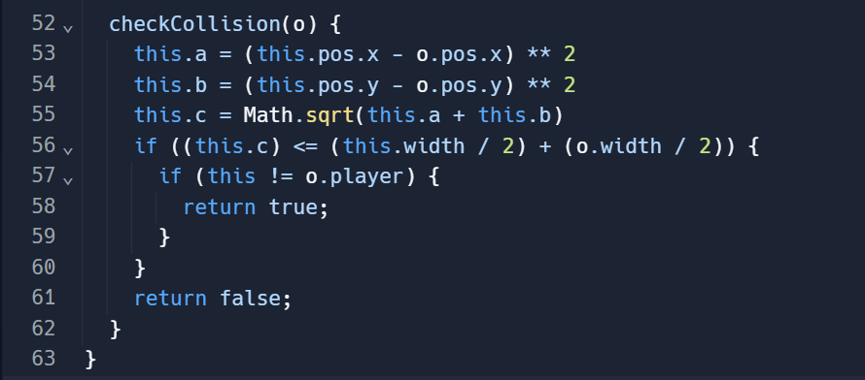
I then created a player loop function in index.js which loops through all the players. It then updates all the players before checking for collision between other objects. This includes the other players, bullets and eventually will also include asteroids. If there is a collision, then it will handle it depending on what collided with.
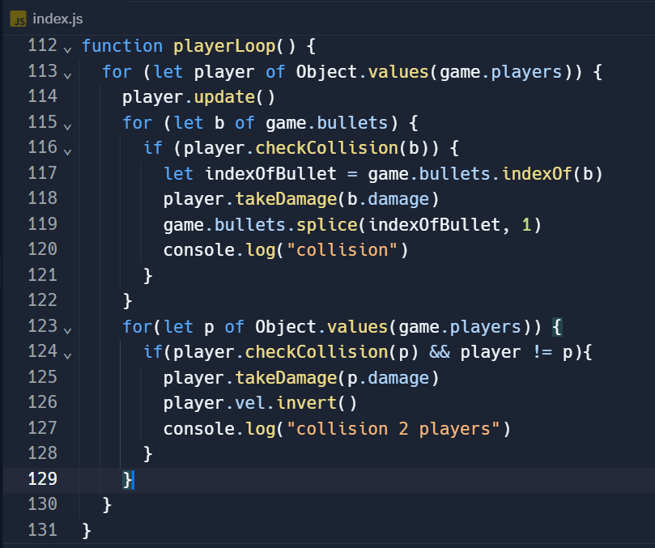
I then quickly wrote another method for the player class to handle the player taking damage. This simply takes the amount of damage dealt and subtracts it from the health of the player.
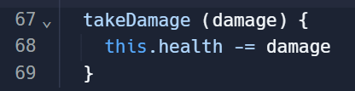

Testing:
I then tested the collisions by shooting players and crashing into them. I saw that the in the console they were being outputted as expected. I had one small issue while developing this as I typed the player position as player.x and player.y instead of the actual player.pos.x and player.pos.y. This meant the collisions were not being detected. After I corrected the spelling, it worked as planned.
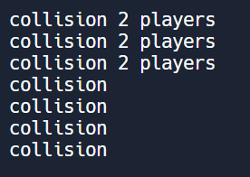

Iteration 9 – M8 – Health System:
I created a draw health bar function which should draw all the health bars above each of the players. First, I drew a rectangle for the whole health bar with no fill and a white outline. I then drew a rectangle with the player’s colour and fills the outline with the amount of health you have relative to the width of the bar. I also rounded the corners of the health bar to make it look a bit cleaner.
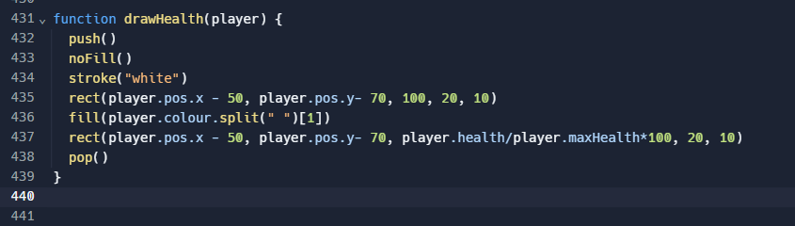
I then put this function in the draw game function just before the screen is translated a second time. This means I can base the coordinates on the top the player coordinates easily.
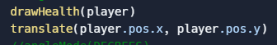
Health can be subtracted by using the damage dealt by the bullet or player from the health. This take damage method is within the player object. Also, within the player object, in the update method I check if the player’s health is less than or equal to zero. If it is, I set the player to not alive and in time I will reset the player attributes to a default before they respawn.
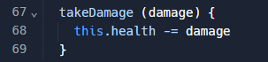
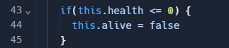

Testing:
I then tested that when the health and health bar reached zero the player died the game screen stopped being drawn.

Iteration 11 – M6 – End Screen:
I then needed to create a death screen to show when the player has died. The screen needed to allow the player to respawn, return to the main menu and see their match statistics.
First, I created a title to show that you have died and who killed you. The amount of kills the player has achieved is shown alongside the length of time the player had survived. To calculate the amount of time the player survived I created a date time object when the player spawn and when the player died. I then used the .getTime() method to get the number of milliseconds since January 1, 1970. I then found the duration of milliseconds by subtracting them. To calculate the minutes, I divided the duration by 60000 and floored the result. The remaining seconds were calculated by subtracting the minutes from the duration and dividing by 1000. I then simply drew the text underneath the number of kills.
Initially, I had issues calculating the time survived attribute as it was showing the
I also show the player’s ship on the right of the screen and I then drew prompts for which buttons to press to continue to the next screen. If I had more time, I could also show the player who killed the player in the background continuing alive.
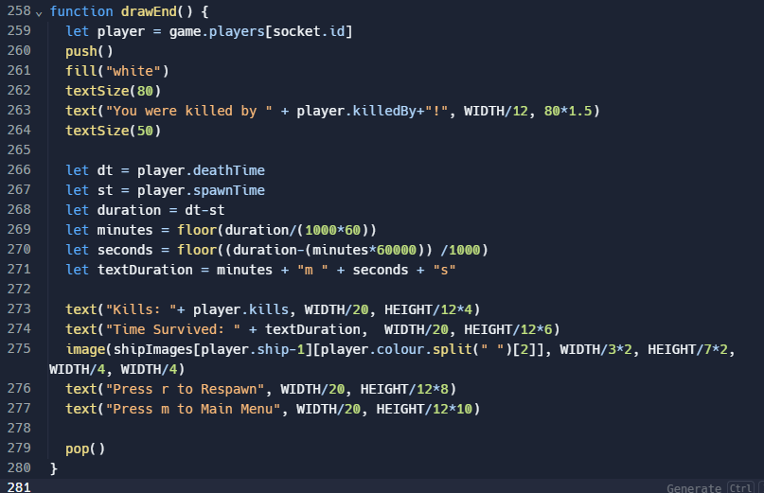
I then wrote a respawn method for the player which should reset the values of the player’s position, velocity, health, spawn time and the alive Boolean. This is called when the player is first spawned and when they respawn.
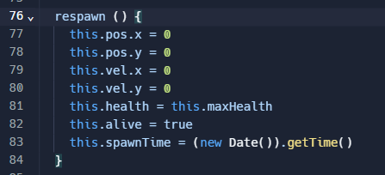
In the player loop I then check if the player health is less than or equal to 0. If it was then I would set the player death time to the time of a new date time object. I also add a kill to the player who killed them. I also set the player’s killedBy attribute to the player's name who killed them. Finally, I set the player’s alive attribute to false.
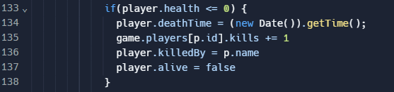

Testing:
To test the functionality of the end screen I played a few rounds with varying time survived and number of kills and they were all accurately represented by the death statistics.
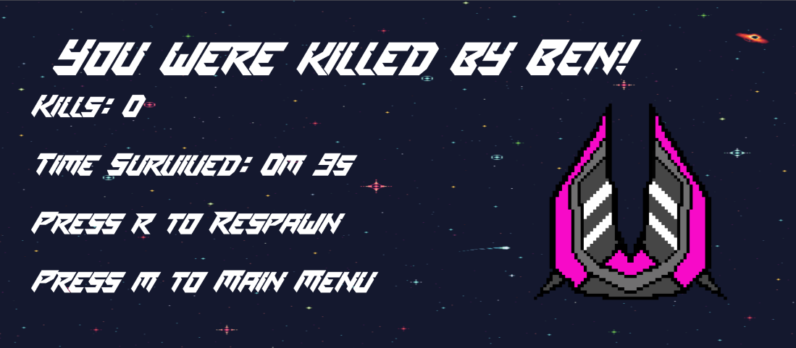

Iteration 12 – S5 – Spawn Points and Space stations:
The main reason I am implementing this should before completing the rest of my musts is that I have decided I only want the player to be able to upgrade their ship at their space station. So firstly, I created a space station class. This takes the player spawn position as its position and has a size of the space station. I also gave the space station a width of the circle around the space station. In this area the player will be able to upgrade their ship. In future versions I will also make player inside this area invincible which means they will not be able to get spawn killed. They will also heal gradually overtime in this area.
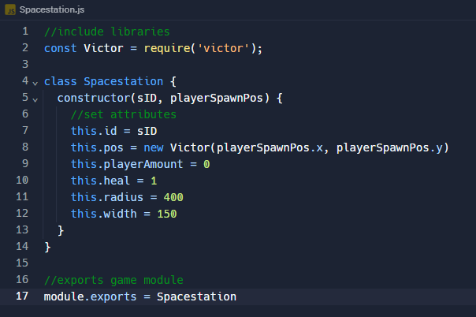
Before drawing the space stations, I quickly implemented a basic map border by drawing a rectangle with no fill with its border at the edge of the map size.
I then looped through the space stations and drew each space station at its position. I then change the ellipse mode to center and draw the circle around the space station.
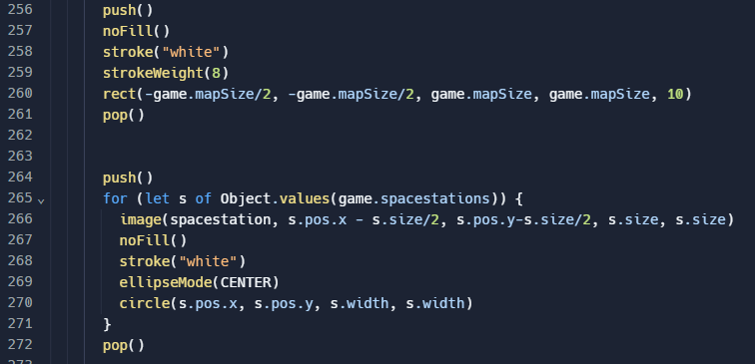
The player spawn position is calculated in the constructor of the player. If there is less than half the maximum number of players and there are no players then the player should spawn, 1 over half the maximum number of players, of the width of the map. This should scale with the number of players in the game.
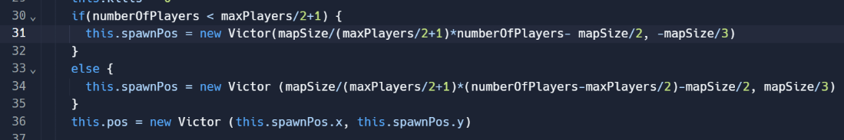

Testing:
At first the space station was in the bottom left of the space station area. This was due to me overthinking how to position these graphics. I attempted to use ellipse mode radius and did not offset the space station by its width and this led to it being in the wrong position. After I made these changes the space station was shown correctly.
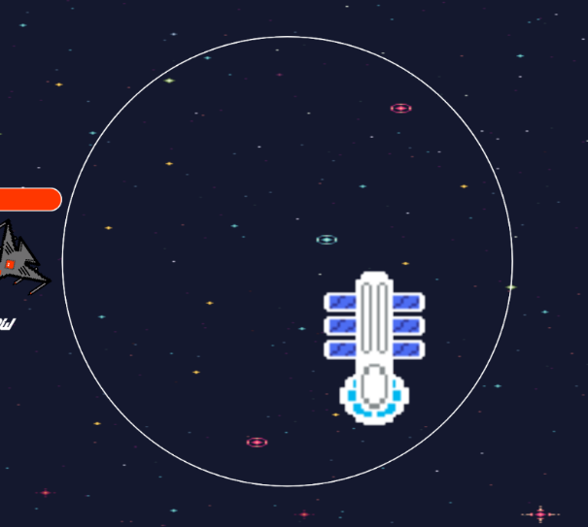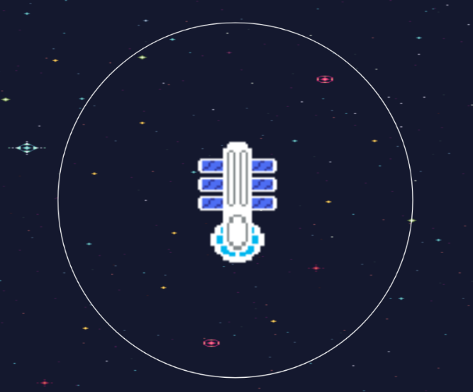

Iteration 13 – M7 – Upgrades:
To be able to afford upgrades the players will need resources. To show the number of resources the player has they will be able to look in the bottom right corner of their screen. Here I drew an image of the resource as well as a number to show the player how many of that resource they have.
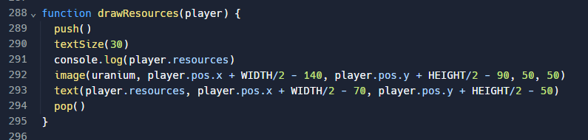
The option to upgrade your ship will be available to players whilst in range of their space station and hidden when outside of that range. In this range you will be able to view a prompt which tells you that you can upgrade your ship by pressing “U” and the upgrade cost.

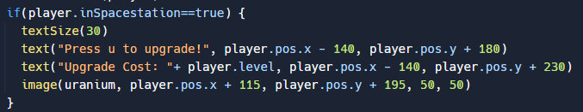
I then made it so the player gained resources one every 5 seconds. This will not be the only way to gain resources, but this works for now and enables the player to upgrade their ship.
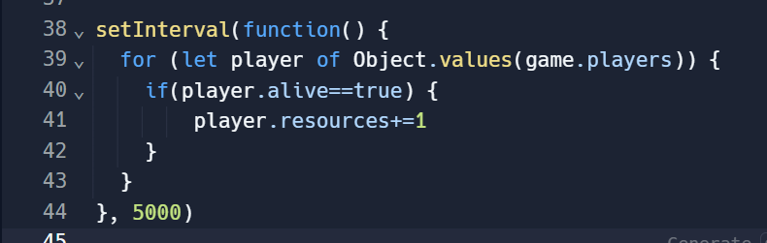
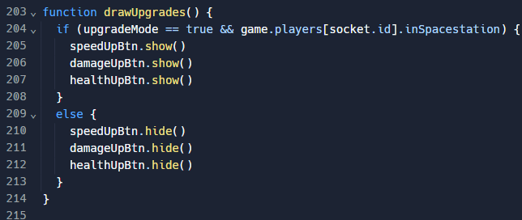
The initial concept for the upgrades for the player ship included creating a new screen to show when the player was within range of their space station. Due to time constraints, I have simplified the implementation of upgrades. The version I implemented shows 3 buttons whilst in upgrade mode. These buttons are to be able to upgrade your speed, damage and health. Upgrade mode is active when in range of the space station and the “U” key has been pressed. The three buttons were given the buttons and upgrade buttons class and positioned centred in the screen.

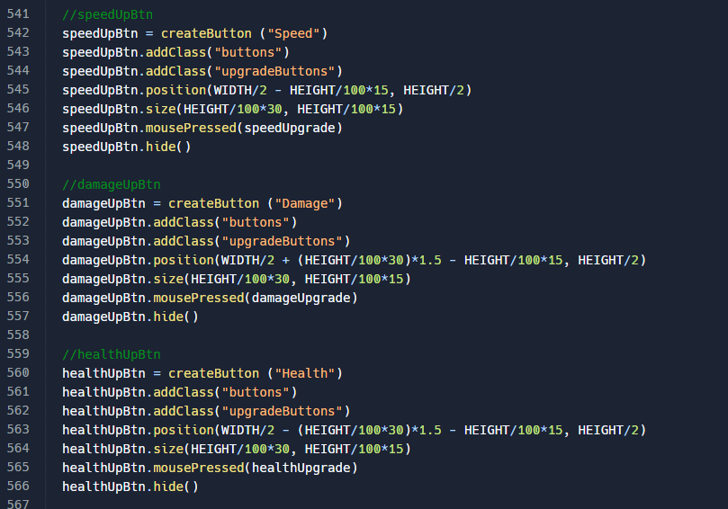
I gave each of the buttons a function to be called when the buttons were pressed. For example, when the health button was pressed the upgrade event with type health was sent to the server.
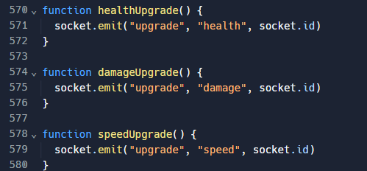
When these are received on the server the player methods to upgrade these attributes are called. Here I increase the attributes by one, increase the player’s level and decrease the player’s resource quantity.
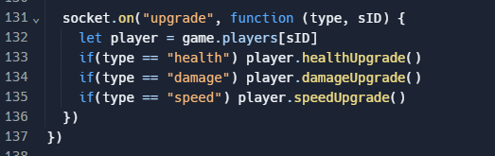
I realised that by implementing these upgrades I could put the player’s resource quantity into the negative. To counteract this, I put an if statement around the upgrade methods to check that the player has enough resources to cover the cost of the upgrade and it will only complete the upgrade if they do.
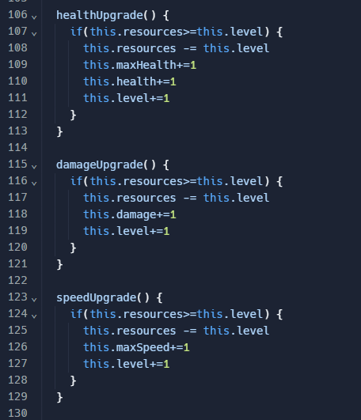

Testing:
I then tested each element of the upgrading functionality. I first tested that being in the range of the space station gave you the prompts to be able to upgrade. It did show and when outside of the range the prompt was hidden.
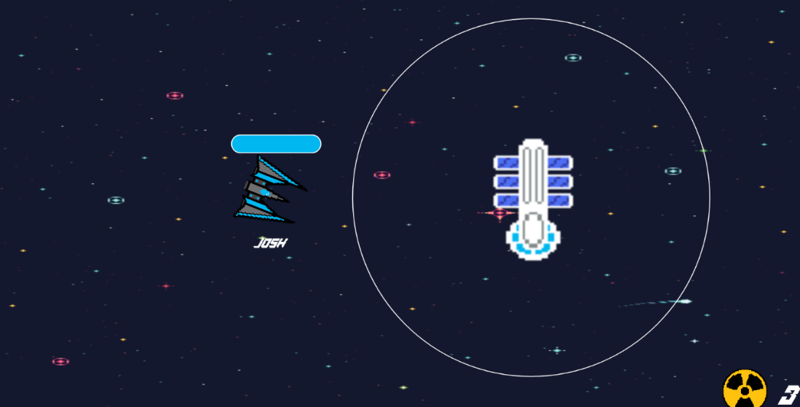
After pressing “U”, the buttons were visible and the buttons correctly reduced the player’s resources based on the cost of the upgrade when pressed.
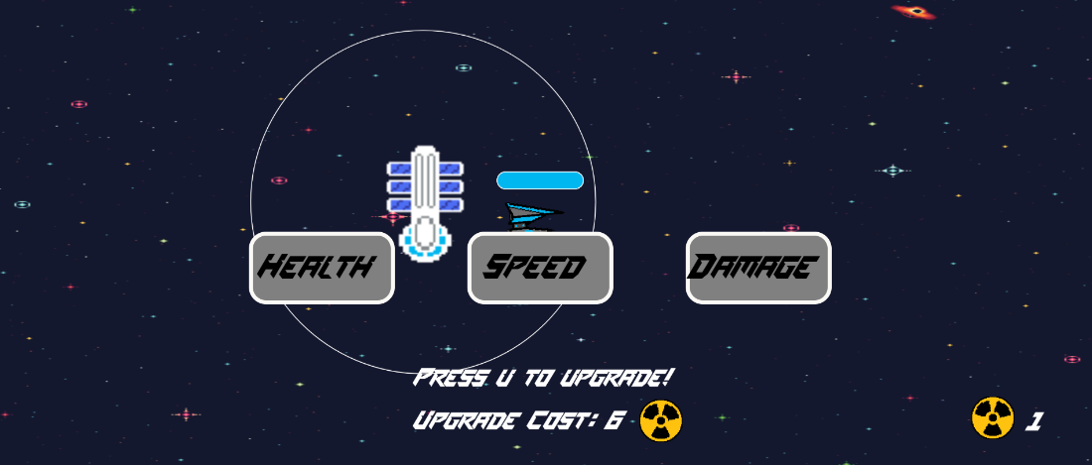

Testing to inform evaluation:
Despite testing each feature as I developed it, it is important to test the current state of the game in its entirety. By completing these tests, I will be able to evaluate if the project has met my requirements, met my stakeholder’s expectations and is a robust product which is not easily broken.

Alpha-Testing:
To complete my alpha-testing, I created a video of me testing my game against each of my predetermined requirements for the success of my project. I went through each test, followed the test instructions and compared the outcome with the expected results.
Test Number | Test Instructions | Expected Result | Test Result (See video)
M1.1 and M1.2 | To test player connectivity is functional press play and move around until you find another player. | Both players should be in the same position on both screens. | 0m 56s
M1.3 | Get two players in a game and get them both in frame. Then disconnect one of them from the server by closing the tab or equivalent. | The player who remains in the game should see the player disappear. | 1m 26s
M2.1 | Once in a game, press WASD and move the player around the map. | The inputs should move the player in the expected direction and their velocity | 1m 43s
M2.2 | Once in the game, move the mouse around the player 360 degrees. | The player ship should be rotated to follow the mouse position. | 2m 14s
M3 | When in the game, click the mouse in a direction. | A bullet should fire in the direction of the player and it should be the colour of the player ship. | 2m 36s
M4.1 | Fire a bullet at another player, so that it hits them. | The bullet should disappear and cause the player’s health to be reduced. | 3m 05s
M4.2 | Move your ship into another player so that they collide. | Both players should lose health and the players should bounce off each other. | 3m 56s
M5 | Fill in any requirements before pressing play. | This should put you in the game. | 4m 50s
M6 | Go into a game and get another player to kill you. | When you die a screen should appear that tells you that you have died and any other relevant information. | 5m 24s
M7 | When in the range of your space station press “U” and attempt to upgrade each of the upgradeable attributes. | When you click on an upgrade your resource amount should decrease and the attribute should be increased. | 6m 03s
M8 | Play a game where you take some damage over time then die. | The health bar should scale to the amount of damage that you have been dealt. When you go to the death screen and die the health bar should be empty. | 7m 19s
S1 | On the start menu, type a name into the input field at the top then press play. | The name should appear centred below the player in the game. | 8m 34s
S2 | On the start menu, select a ship from the select 4 and then press play. | The selected ship should be displayed as the player character. | 9m 36s
S3 | Play a round and then die. | The time survived should be accurate and the number of kills should be the same as the amount of time you killed enemy players. | 10m 10s
S4 | Once in the game, wait for a few seconds then attempt to upgrade your ship beyond what you can afford. | Every five seconds you should receive 1 resource point. When you upgrade the resource points should decrease but should not be able to go into the negative. | 10m 58s
S5 | Press the play button and spawn in. Repeat this until the maximum players is reached. | Check that each player has spawned at their own space station. | 11m 54s

The following requirements were not tested as I did not attempt to implement them within my project within the given time restraints:
- S6 How to Play
- S7 Direction Indicator
- S8 Sound effects
- S9 Current Scores Leader board
- C1 Meta Upgrades
- C3 Boost
- C4 Bullet Recoil
- C5 Mini map
- C6 AI enemies
- C7 Account System
- W1 Game Modes
- W2 Friends
- W3 Multiple Rooms

Stakeholder Testing To Inform Evaluation:
Within this test I gave this table to 2 of my stakeholders and allowed them to complete this testing. They may be able to find issues with the game that I could not. This will include general functionality of each feature as well as some robustness testing where the players will attempt to do things which may have the potential to break the game.
The two stakeholders who I gave the code to test were [1] Lloyd and [2] Felix.
Test Number | What you should do | Comments
1 | Try to start a game without selecting a name, ship or colour. | [1] When I tried to enter the game without selecting any, it would not allow me to proceed to the start. However, when I didn't select a colour or a ship I could proceed. It seems to work well, and I wasn't able to identify any way to break it. It works very well, and the experience was seamless.  [2] If you try and start a game without selecting a name or ship type, the game will not let you. I liked how the borders changed around the buttons based on what options you had selected.
2 | Start a game with various length names using various unusual and usual characters. | [1] When putting in different name lengths it's good to see that there is a reasonable limit on the number of characters a person can have. However, once I enter the game if I have a particularly long name, it is not centred correctly on my sprite. It isn't particularly aesthetically pleasing but does not affect gameplay. Furthermore, you can pretty much put whatever you want in - a filter may be preferrable to prevent harmful names.  [2] I found that if you copy and paste text into the name box it allows you to type infinite characters until the game crashes, I also found that there is no filter for special characters. Overall, though the ship selection screen worked well.
3 | Move the player ship around with many inputs at once and changing direction often. | [1] The game acts robustly to all sorts of spammed inputs. The ship glides smoothly across the screen and changing of direction feels realistic with a slight drag before you can actually move to your desired location.  [2] Moving the player ship around I did not find any errors.
4 | Move the mouse around the player all 360 degrees. | [1] The game, again, responds well overall to the spinning of the mouse around the player. It does glitch about a bit as you spin a full 360.  [2] The ship faced the cursor when spinning the cursor 360 degrees.
5 | Fire bullets in all directions while stationary and moving. | [1] When firing the bullets, some of my key presses do not register (if I'm clicking particularly fast) when I'm clicking my mouse, but it is a minority of instances where this happens. When clicking, the bullets all go in the correct directions which is good. There are no issues with shooting when stationary and this is possible.  [2] The game allowed me to fire bullets in all directions without issues even when I was moving around.
6 | Fire bullets very close to players to see if the hit boxes are accurate. | [1] Hitboxes are overall very good and very functional. There are some disparities with the actual hitbox themselves and sometimes you can shoot the corner of a person's ship and it doesn't make them take any damage. Even up close the bullets still do full damage.  [2] When firing at other players the hitboxes worked correctly and seemed to be accurate.
7 | Crash into the map barrier and try to leave the map. | [1] In general, it is difficult to escape the map boundaries - but not impossible. I was able to get out of the map by going into the wall and then swapping my A key for the D key which then put me in the wall, and I was able to escape. However, you cannot do anything outside of the map wall such as shoot, and you move incredibly slowly so it's not a massive issue overall.  [2] The barrier mostly worked but if you hit it at a weird angle, you could sometimes phase through it and leave the map.
8 | Take an excess of damage to your health. | [1] I was not able to get into negative damage - I was killed by the game before that was able to occur. I tried this numerous times and wasn't able to get into negative health. Overall, this feature is functional, and the death screen is also good. It displays lots of useful stats about the player's time in the session.  [2] When you run out of health the game over screen is displayed correctly.
9 | Take damage then upgrade your health. | [1] Upgrading health whilst damaged is possible and this increases the player's health by a tiny bit. I did not have enough radioactive stuff to get back up to full health, however. I wasn't sure whether upgrading health whilst at full health did anything, but it became apparent that upgrading the health whilst at full health meant you took less damage against other players.  [2] When you upgrade your health after being damaged, your health is not fully replenished.
10 | Measure the time you survive in a round and compare this to the death statistic shown when you die. | [1] When playing I used a stopwatch to determine the time it took for me to die - I then died and observed the time displayed on screen. This was accurate to the time elapsed since the game started. I wasn't able to find any way to break this mechanic itself and overall, the screen is useful for displaying player stats.  [2] When measuring how long I survived for then comparing it to the death statistics it was correct. However, I would have enjoyed if there were more statistics such as upgrades made or accuracy.
11 | Count the number of kills you get and compare this to the kills shown when you die. | [1] When killing others, the game is able to accurately record the number of people I killed - I tried this numerous times and tried ranging from 0 to 20 kills per round and they all were recorded accurately. One thing I would change about this, it would be to better visually display this with icons as there's a lot of clutter with all the words on the screen.  [2] The number of kills corresponded with the number on the death screen.
12 | Check that when you spawn in you end up in your own space station. | [1] You do spawn at the same space station from the start - I noticed you can only upgrade at your station but having gone around the map I couldn't actually figure out what one was mine so I think this could be an area for improvement - making an identifiable way to see it is your space station and perhaps an indicator to direct you to it when you're halfway across the map.  [2] When I spawned in, I would not always spawn in at the correct space station and this caused issues where I would die instantly because a player was at the space station.
13 | Attempt to upgrade your ship at a space station of another player. | [1] As mentioned above, I was not able to upgrade my ship at another space station. However, I did make comments above about how the location of these space stations can be improved.  [2] The game allows you to upgrade your ship at other people’s space station.
14 | Try to buy an upgrade you cannot afford. | [1] I was unable to purchase an upgrade I couldn't afford (I think). I think the upgrades lacked any visual confirmation aside from your radioactive substance. I feel as though maybe a sound, or a popup would be ideal for this.  [2] The game will not allow you to purchase upgrades you cannot afford.
15 | Check that the upgrades affect your ship as expected. | [1] All upgrades work as intended on the upgrades screen. However, if you get killed whilst on this screen, then you end up with the UI stuck on your screen forever. This is obviously not ideal in this regard.  [2] When upgrading your ship there is a noticeable difference. This has only been problematic when upgrading damage as you only need a couple of upgrades to kill new players in 1 or 2 bullets.
16 | Usability | [1] I think overall the game is usable and all of the tests carried out are evidence of this. One of my main complaints is that the game can become unusable when one person has upgraded their health/damage too much as you instantly die with one shot. Perhaps a limit or a cap would be appropriate to prevent these being upgraded exponentially.  [2] Overall, the game is easy to understand and it is made clear how each feature of the game works.
17 | Functionality | [1] I noticed that when you die, your background continues to scroll at the speed you were going when you actually died. This is just a small thing which could be fixed to give the game a more uniform effect. Overall, I think that the game functions well and all the features are functional and pretty much work as intended.  [2] Overall, I liked the different functions of the game and felt that they were all well implemented and functioned as I expected. I really enjoyed the fact I could play with my friends and the interactions between us were really fun.
18 | Robustness | [1] When firing bullets at a target for a prolonged period they begin to not travel far enough at all it seems. They seemingly destroy themselves before they reach the player, so the robustness of the bullet firing feature needs to be looked at to identify why exactly this is happening. Overall, it is quite a robust game but is slightly rough around the edges with some metrics such as the map boundaries able to be avoided just don't make it as well rounded as it could be.  [2] Overall, the game is reasonably robust but I was able to break the game a few times.

Evaluation:

Success Criteria Evaluation:
Since I have tested my game and received feedback from each of my stakeholders, I can now start to evaluate my game against each of my MoSCoW requirements.

M1 - Multiplayer Connectivity:
I believe multiplayer connectivity is a success as you can play with up to 6 players in real time. Player interactions are smooth, fun and Felix said, “I really enjoyed the fact I could play with my friends and the interactions between us were really fun”. There is a small amount of latency which is visible but this is minimal and not off putting while playing. If I were to develop the game further, it would be beneficial to implement some features to make the gameplay smoother and decrease latency. I researched player interpolation, client-side prediction and server reconciliation but did not have time or experience to implement in the initial version.

M2 - Player Movement:
Player movement is a critical part of this game and overall, I would deem this criterion a success as you can move using WASD and when testing Lloyd thought that “The ship glides smoothly across the screen and changing of direction feels realistic with a slight drag before you can actually move to your desired location”. I agree and think that the movement mechanics add to the feel of the game in a positive way.

M3 – Bullets:
Overall, bullets are working, and you can shoot them in any direction around the player using the mouse. While Felix was testing the game, he was able to shoot bullets where he wanted “without issue”. On the other hand, Lloyd found an irregular bug where, “some of my key presses do not register (if I'm clicking particularly fast)”. This is slightly concerning as it is important bullets are working to be able to kill enemies. One fix that may be possible is giving a cooldown between each time a bullet is shot. I would say that the requirement is met as, on the whole, few issues are being had when shooting bullets.

M4 – Collisions:
I believe the criteria for collisions has been met as players can collide with each other, bullets and the map border. When players are colliding with other players their velocity is inverted so they bounce off each other. One thing in that regard which could be improve is that some of that velocity should be passed on to the other player. Bullets, overall, can collide with players and the hitboxes are mostly accurate. While beta testing Lloyd thought that, “sometimes you can shoot the corner of a person’s ship”. This is likely caused by the ship hitboxes being modelled as circles and it would obviously be more accurate with custom shapes. On top of this, there is also an issue with colliding with the map borders. Both stakeholders appeared to experience this problem. Felix described the issue by saying, “The barrier mostly worked but if you hit it at a weird angle, you could sometimes phase through it and leave the map”. I have been able to recreate this issue and while it is not an intended or good feature while outside the map both me and Lloyd feel that “you cannot do anything outside of the map wall such as shoot, and you move incredibly slowly so it's not a massive issue overall”. Despite this, Felix found that, “hitboxes worked correctly and seemed to be accurate”. Therefore, I conclude that this requirement was a success because the function of collisions do not negatively affect the gameplay and is generally very accurate.

M5 – Start Screen:
The start screen is one of my favourite screen designs within my project. It shows up when you first load in and you can return to it from the death screen. It provides you with a few options to configure before going into the game. Lloyd found that the start screen, “works very well, and the experience was seamless”. This is the experience that I wanted people to have and ease them into the game without throwing them straight into the action. It also gave me the best way to implement other features such as ship select, ship colour and name picker. Overall, the start screen was a success and I am very happy with the outcome of it.

M6 - End Screen:
Within the end screen, I differed from my design due to time restraints and still maintain that buttons to respawn and return to main menu would have been more appealing. However, Lloyd had positive feedback surrounding the screen and said that “The death screen is also good. It displays lots of useful stats about the player's time in the session”. I concur with this and think the statistics add to this screen and I think it looks good overall. Another issue I have found with the end screen is that when you die while moving, the death screen background keeps moving at that speed. I did not mind the aesthetic of this and inspired me that in the future it would be interesting to spectate the player who killed you in the background. I would say that the death screen was only a partial success as there a few changes which it would benefit from which I set out to be standard.

M7 - Ship Upgrades:
Overall, I would say that this requirement was only a partial success due to time restraints. The upgrades can be bought only from your space station within the area. This means throughout the game you are encouraged to come back to upgrade your ship. When within the area you are given a prompt to open an upgrade menu using “U”. This prompt may look better and more minimal as a button with an upgrade icon. While in this menu when pressing buttons to upgrade you are also clicking to fire a bullet. While this has no adverse effects, this is not an intended function. Generally, Lloyd found “the upgrades lacked any visual confirmation” and that sounds to confirm the upgrades could also be useful. The main issue with the menu screen is that if you die with the screen up, then the screen overlays the death and menu screens until you go back into the game. This would be fixed with further development of space stations where players may be invincible within its area, however, this is a large issue and shows a lack of robustness of this feature.

M8 - Health System:
The health system is robust and successful in deciding whether a player is alive or dead. The player health is displayed by a health bar with a fixed width above the player. When the player is hit the health bar becomes less full until it is empty and then the player is considered dead. When the player’s health is decrease by damage or increased by an upgrade there is no animation to clearly show what has changed. This would lead to less confusion with the health bar and make for a better experience. I would say that this requirement has been met successfully.

S1 - Name Picker:
Overall, I believe this feature has been implemented successfully, however, there have been a few oversights when ensuring robustness of this feature. One issue which Felix found with the input field is that, “if you copy and paste text into the name box it allows you to type infinite characters until the game crashes, I also found that there is no filter for special characters”. This is an issue which could be easily fixed but causes issues for the performance of the game. Saying this, when typing normally the character cap is 12 and this functions as expected. I also noticed that for some name lengths the name is not centred correctly on the player ship. Lloyd also pointed out that “a filter may be preferrable to prevent harmful names”. I did not consider this but could be an important feature to add in the future.

S2 - Ship Select:
The ability to select the ship you would like to use is easy to use and works as expected. Lloyd found that, “the experience was seamless”. You can select one of 4 different ship types to use within the game. There is one small issue with the buttons on the start screen occurs when they are clicked and the active CSS class is given to them. This class changes the border weight to a thicker line and as a result changes the alignment of the button in some resolutions. This does not look professional but has no functionality implications. There is a default one assigned the active class which means there is no way to break the game by trying to go into a game without a ship selected. This feature is very robust and I am pleased with how I have implemented it. Therefore, I would say that this requirement has been met successfully.

S3 - Death Statistics:
Overall, I think the implementation of death statistics to the death screen has been successful. The two statistics which I implemented were time survived and number of kills. These were calculated correctly and reset for each life of the player. Felix said, “I would have enjoyed if there were more statistics such as upgrades made or accuracy”. I think that these statistics fit well within this game and could be added in future versions. I think that there should be a better more readable way to view these such as using icons instead of text. This would likely fix Lloyd’s concern that there is “a lot of clutter with all the words on the screen”. I believe that the requirement has been met successfully as the players when they die are able to view how they performed by seeing 2 accurate data points which I set out to include.

S4 – Resources:
I would say that the implementation of this requirement was a partial success. You can gain one resource type which enables you to upgrade your ship. However, the only way to gain resources is by getting one every 5 seconds. I would have preferred you to be able to gain resources from other players and asteroids in addition or alternatively to this. The uses for resources were initially planned to be used for unlocking new ships, however, I did not have time to introduce this feature. This feature has been made more robust by ensuring that the player’s resource cannot go below zero and the resource counter is clearly shown in the bottom right of the screen using an icon.

S5 - Spawn Locations:
Overall, I believe that meeting the spawn location requirements are a partial success. Most of the time, you spawn at a unique space station equally spaced throughout the map. However, throughout Felix’s time testing the game he seemed to find that, “I would not always spawn in at the correct space station and this caused issues where I would die instantly because a player was at the space station”. I believe this issue occurs in a very specific circumstance and has not been a problem experienced by many players. For example, Lloyd did not have this issue but he did have some feedback where, “I couldn't actually figure out what one was mine so I think this could be an area for improvement - making an identifiable way to see it is your space station and perhaps an indicator to direct you to it when you're halfway across the map”. This is an issue which would affect the usability of the game and together with the periodic bug make this requirement a partial success, despite the core of the feature working correctly.

C2 - Ship colour:
The ability to choose the colour of your ship on the start screen was implemented successfully. I have tested this feature many times and have failed to find an example where I has not worked as expected. I also gave one colour the active class by default to ensure this feature was robust. Without adding this addition, the player may be able to go into the game without a colour and this could cause an issue with working out which sprite to show the player ship as.

Assessment of Usability Features:
Throughout the development of the game, I have tried to make the game easy to use and intuitive. Overall, I feel that there are some features where this shows and others where there is more work to be done.

Start Screen:
Overall, I feel that I have added features to make the start screen easy to use and understand. Firstly, when each button is pressed it is given a CSS class named active to show that it has been selected. This class increases the border weight of the button and therefore makes it obvious which option is selected currently. I have also set that when a colour is selected some of the borders are changed to that colour. This reinforces to the player that a lot of the UI moving forward is going to be that colour. These features guide the player through the start screen and help to make it easier to start a game. Felix “liked how the borders changed around the buttons based on what options you had selected” and Lloyd thought that the “experience was seamless”.
However, there are a few features which I believe could use refining to make the start screen even more usable and user friendly. The main one of these is the name picker. One tweak to this would be a placeholder text or label to show that the box is for inputting a name of the player’s choosing. A simple ‘Please Enter Your Name Here:’ would just make the screen a bit more usable. Another way it could be made more user friendly is that when you reach the maximum character count a small prompt should appear telling you this. This would be a good addition to simply blocking the player’s ability to type beyond the character cap. One last feature on the start screen which could use improvement is the play button. The button is static and does not change when hovered or the conditions are met to play the game. It would aid the player in knowing how to continue if the button was greyed out until the requirements to play are met. Then way the player hovers the button it changes slightly to show that the button can be pressed.

Health System:
While the health system is very robust and while testing my stakeholders had no issues the functionality of the system there are few ways that I feel the visual representation of the player’s health could be improved to increase the usability of this feature. For example, while Lloyd was playing the game, he “wasn't sure whether upgrading health whilst at full health did anything”. This is an issue as the health bar is a fixed width and there is no animation for a change in health. I could in future version make the health bar increase in length when it is upgraded and add an animation where is visibly increases in size. The player health could also be animated within the health bar to show when it increases/decreases. This would remove any confusion of how the player health is displayed and overall improve the gameplay experience. On the other hand, one way the health bar has been made usable is that it is attached to each player so that it is clear what each player’s health is.

Upgrades:
Due to the upgrade system being one of the last features that I implemented into my game, I have neglected a few usability features within this area. Despite this, I feel that the upgrades are robust as you can only buy upgrades when you can afford them, when in your space station and with the upgrade menu open. However, during stakeholder testing Lloyd felt that “the upgrades lacked any visual confirmation”. I agree with this comment and believe that a hover effect on the buttons and an animation or way to see your level increase would give the player a better experience. A player would also benefit from being able to see how many upgrades they have put into each stat. One usability feature which was successfully built into the upgrades is that when the ship leaves the space station area the upgrade menu is automatically closed. Additionally, when the player returns to the area, the menu opens for them. This reduces button presses for the player and enables them to do upgrades quickly if they are in a rush to do so.

Maintenance issues:

Multiplayer issues:
One of the main issues with the maintenance of the project is that if it became a popular game then the maximum player cap of 6 would be problematic. Instead of having one game running at once, I would need to create the ability to join different rooms. Socket IO has easy integration for this, but I simply did not have time to allow for this in the initial version. The game may also benefit from larger rooms with more than 6 people as I feel like the game would be more fun with more players and would allow for larger groups of friends to battle it out or work together to take others out.

Server Usage:
Another issue with the maintenance of my game is that currently the game is quite server intensive. This is because I did not have a lot of server-side development experience and did not know many best practices. This meant that I do most of the calculations and loops on the server which when running at a high frame rate can be intensive on the server. That is why currently the game is capped at 20 frames per second. If the game was to be developed further, it is important that the code is optimised so that more load is shifted on to the client.

Limitations of the project:

Player Progress:
Currently, the game does not save any of the player’s progress but I feel that if the player had things they could unlock over time, then they would want to play the game for longer. One example of things the play could save into other sessions are some types of upgrades, ship types or more colour options. However, this would not be very easy to add quickly to new versions as there is currently no database set up to store account information or implementation of player accounts to store this information against.

Upgrade System:
One limitation of the current state of the project is the simple nature of the upgrade system. Initially, I had designed an entire upgrade screen with many different types of upgrades, however, due to time restraints I was not able to implement this fully. I feel that if I was able to add a wider choice of upgrades and more ways to obtain potentially different resources then the player would have a lot more choices on how they played the game.

Potential Further Developments:

Mini map:
During testing it became obvious that the game would be more fun with more player fights and interactions. This could be encouraged by having a mini map which shows where each player is and where their space stations are located. This would not only prevent some of my stakeholder’s issues with finding their space station but also encourage players to hunt others down.
To develop this, I would start by drawing a rectangle to represent the map on the screen. This would have to be a percentage of the screen size. I would then map all the relevant coordinates to be in the same ratio of the screen size and have temporary variables to store these coordinates. I would then use those coordinates to draw a symbol or dot to represent different objects such as players and space stations. This would create a basic but effective way to see where you are in the map relevant to other players.

Account system:
I believe that having an account system will enable a wide variety of features to be added in the future such as save data and friends. You would in time be able to save your upgrades and unlock and keep new ships. Being able to join games specifically with your friends may be more fun for the player as it would allow them to work together or against each other.
To implement this feature, I would need to add a database to my project. I would likely choose an SQL database as that is what I am most familiar with and it fits the type of data I will be storing. I would need to store a username, id, password and any other data I am storing about player’s upgrades or unlocks. I would then need to create a page to sign up, sign in and manage your account. An alternative to doing this, I could use a third-party service such as google to allow people to sign in using an external account. This would reduce the workload for development, however, I would lose some control over how I can save data. Personally, I would have like to develop my own Login and account system, predominately as a learning experience and also it would allow me to better integrate my save data and friends into the server. Each player in the database would have a unique identifier which would be created when a new account is created. Each record would also store the username and password of the player. It is then likely that I would store a JSON formatted string containing the upgrades and unlocks that the player has. This can then be reference when a player signs back into their account to retrieve their previous progress.

Leader board:
Initially, I intended to create an in-game leader board to contain the current scores / levels of each player that is alive. This would have given players and opportunity to see who the most powerful ship is and hence who to avoid. This would give players the ability to think about strategy and not just blindly fly around and spray bullets at whoever.
To store the needed information for the leader board I would create a JSON file on the server-side. I would use a key of the player names and value of their score / level. I would then draw the leader board each time the file is updated with a new score or name. In drawing the leader board, I would need to sort the objects in order of the highest score / level value. I would the pick the highest few to draw on the leader board. I should also do a check if one of these players is you and if they are then your name should be written in bold to show this. To do this I would need to loop through each of the objects in the JSON file and collate a list of the top five scores each time the file is updated with a new score.

END

Code:

Index.html:
<!DOCTYPE html>
<html lang="en">
<head>
<meta charset="UTF-8">
<meta http-equiv="X-UA-Compatible" content="IE=edge">
<meta name="viewport" content="width=device-width, initial-scale=1.0">
<title>Spacecraft Evolution</title>
<script src="https://cdnjs.cloudflare.com/ajax/libs/p5.js/1.5.0/p5.min.js" integrity="sha512-WJXVjqeINVpi5XXJ2jn0BSCfp0y80IKrYh731gLRnkAS9TKc5KNt/OfLtu+fCueqdWniouJ1ubM+VI/hbo7POQ==" crossorigin="anonymous" referrerpolicy="no-referrer"></script>

<script src="https://cdnjs.cloudflare.com/ajax/libs/p5.js/1.5.0/addons/p5.sound.min.js"></script>
<script src= "socket.io/socket.io.js"></script>
<link href="style.css" rel="stylesheet">
</head>
<body>
<script src= "sketch.js"></script>

</body>
</html>

Style.css:
@font-face {
font-family: spaceFont;
src: url(assets/fonts/SpaceMissionFont.otf);
}

body {
overflow: hidden;
padding: 0px;
margin: 0px;
}

.buttons {
border-style: solid;
border-radius: 20px;
font-size: 60px;
color: #FAF9F6;
border-color: #FAF9F6;
border-width: 5px;
text-align: center;
font-family: spaceFont;
}

.greenButton {
background-color: #1ded40;
}

.blueButton {
background-color: #00B7ef;
}

.pinkButton {
background-color: #f70ac8;
}

.orangeButton {
background-color: #ff3700;
}

.colourButtons {

}

.shipButtons {

}

.upgradeButtons {
color: black;
background-color: grey;
padding: 5px;
font-size: 40px;
}

.playButton {
color: black;

}

.active {
border-width: 10px !important;
}

.shipButtons {
background-color: grey;
}

.inputs {
border-style: solid;
border-radius: 20px;
font-family: spaceFont;
border-width: 5px;
font-size: 40px;
text-align: center;
}

Sketch.js:
//setup socket connection
let socket = io();

//define globals
let game = null
const WIDTH = window.innerWidth
const HEIGHT = window.innerHeight
let canvas
let font
let bg

//globals for spacestation, upgrades and resources
let spacestation
let upgradeMode = false
let uranium

//ship images
let shipImages

let ship1blue
let ship1green
let ship1orange
let ship1pink
let ship2blue
let ship2green
let ship2orange
let ship2pink
let ship3blue
let ship3green
let ship3orange
let ship3pink
let ship4blue
let ship4green
let ship4orange
let ship4pink

let bPos
let bVel
let mPos
let previousMPos
let a

let currentShip

//define buttons and inputs
let nameInp
let playBtn
let blueBtn
let pinkBtn
let greenBtn
let orangeBtn
let speedUpBtn
let damageUpBtn
let healthUpBtn

//ship buttons and images
let ship1Btn
let ship2Btn
let ship3Btn
let ship4Btn
let ship1BtnImg
let ship2BtnImg
let ship3BtnImg
let ship4BtnImg

/*
* Function built into p5 which preloads images
* and assets before running the project
*/
function preload() {
bg = loadImage("assets/imgs/spacebg.png")

spacestation = loadImage("assets/imgs/spacestation.png")

uranium = loadImage("assets/imgs/uranium.png")

ship1BtnImg = loadImage("assets/imgs/buttons/ship1Grey.png")
ship2BtnImg = loadImage("assets/imgs/buttons/ship2Grey.png")
ship3BtnImg = loadImage("assets/imgs/buttons/ship3Grey.png")
ship4BtnImg = loadImage("assets/imgs/buttons/ship4Grey.png")

ship1blue = loadImage("assets/imgs/ships/ship1Blue.png")
ship1pink = loadImage("assets/imgs/ships/ship1Pink.png")
ship1orange = loadImage("assets/imgs/ships/ship1Orange.png")
ship1green = loadImage("assets/imgs/ships/ship1Green.png")

ship2blue = loadImage("assets/imgs/ships/ship2Blue.png")
ship2pink = loadImage("assets/imgs/ships/ship2Pink.png")
ship2orange = loadImage("assets/imgs/ships/ship2Orange.png")
ship2green = loadImage("assets/imgs/ships/ship2Green.png")

ship3blue = loadImage("assets/imgs/ships/ship3Blue.png")
ship3pink = loadImage("assets/imgs/ships/ship3Pink.png")
ship3orange = loadImage("assets/imgs/ships/ship3Orange.png")
ship3green = loadImage("assets/imgs/ships/ship3Green.png")

ship4blue = loadImage("assets/imgs/ships/ship4Blue.png")
ship4pink = loadImage("assets/imgs/ships/ship4Pink.png")
ship4orange = loadImage("assets/imgs/ships/ship4Orange.png")
ship4green = loadImage("assets/imgs/ships/ship4Green.png")

font = loadFont("assets/fonts/SpaceMissionFont.otf")

}

/*
* Function built into p5 which is runs once
*/
function setup() {
//stores ship images by index of ship type then colour
shipImages = [
[ship1blue, ship1pink, ship1orange, ship1green],
[ship2blue, ship2pink, ship2orange, ship2green],
[ship3blue, ship3pink, ship3orange, ship3green],
[ship4blue, ship4pink, ship4orange, ship4green]
]

canvas = createCanvas(WIDTH, HEIGHT)
textFont(font)
frameRate(20)

//create all DOM inputs
createInputs()

//set vectors for background to 0
bPos = createVector(0, 0)
bVel = createVector(0, 0)

//set vectors for mouse position to 0
previousMPos = createVector(0, 0)
mPos = createVector(0, 0)

//listens for gamestate events
socket.on('gamestate', function(data) {
//update game data
game = data
bVel.x = game.players[socket.id].vel.x
bVel.y = game.players[socket.id].vel.y
bPos.x = (bPos.x - bVel.x)
bPos.y = (bPos.y - bVel.y)
socket.emit("changeScreenSize", WIDTH, HEIGHT, socket.id)
//from = createVector(WIDTH/2, HEIGHT/2);

})

//if mouse if moved then update mouse angle
calculateAngle = function() {
previousMPos = mPos
//if(mPos.x == previousMPos.x || mPos.y == previousMPos.y && game.players[socket.id]) {
socket.emit("calculateAngle", {x: mouseX,
y: mouseY}, socket.id)
previousMPos.set(mouseX, mouseY)
//}
}
canvas.mouseMoved(calculateAngle)

}

/*
* Function built into p5 which runs every frame
*/
function draw () {
//set mPos vector to current mouse positions
mPos.set(mouseX, mouseY);

drawBG()

//check what screen to draw
if(game) {
if(Object.values(game.players).length>0){
//gameplay screen
if(game.players[socket.id] && game.players[socket.id].alive == true){
drawGame()
movement()
}
//death screen
else if (game.players[socket.id] && game.players[socket.id].alive == false) {
drawEnd()
}

//start screen
else if (game.players[socket.id] && game.players[socket.id].alive == null) {
drawStart()
}
}
}
}

/*
* This function checks the WASD inputs
* and if there is a key pressed then
* the move event is sent to the server
*/
function movement() {
//if w key pressed down
if (keyIsDown(87)) {
socket.emit("move", "w", socket.id)
}
//if s key pressed down
if (keyIsDown(83)) {
socket.emit("move", "s", socket.id)
}
//if a key pressed down
if (keyIsDown(65)) {
socket.emit("move", "a", socket.id)
}
//if d key pressed down
if (keyIsDown(68)) {
socket.emit("move", "d", socket.id)
}
}

/*
* Function built into p5 which is called when any key is released
* sends key release event to the server
* and checks for U button press for upgrade mode toggle
*/
function keyReleased() {
//sends server the key that was just released
socket.emit("keyRelease", key, socket.id)

let player = game.players[socket.id]

//check if player wants to upgrade
if(player && player.alive==true && key == "u" && player.inSpacestation == true) {
if(upgradeMode==true){
upgradeMode=false
}
else {
upgradeMode=true
}
}
}

/*
* Shows or hides upgrade buttons based on:
* whether upgrade mode is true and
* the player is within their space station
*/
function drawUpgrades() {
//show upgrade buttons
if (upgradeMode == true && game.players[socket.id].inSpacestation) {
speedUpBtn.show()
damageUpBtn.show()
healthUpBtn.show()
}
//hide upgrade buttons
else {
speedUpBtn.hide()
damageUpBtn.hide()
healthUpBtn.hide()
}
}

/*
* Function built into p5 called on every mouse press
* sends mouse click event to the server
*/
function mousePressed() {
//if mouse is wihtin the screen
if (mouseX > 0 && mouseY > 0 && mouseX < WIDTH && mouseY < HEIGHT) {
socket.emit("mouseClick", mouseX, mouseY,socket.id)
}
}

/*
* draws the players, bullets, map border,
* space stations and upgrade prompts
*/
function drawGame () {
//draw gameplay screen
hideStartInputs()
if(game) {
if(Object.values(game.players).length>0){
translate(WIDTH/2 - game.players[socket.id].pos.x, HEIGHT/2 - game.players[socket.id].pos.y)
for(player of Object.values(game.players)){
//for each player
if(player.alive == true) {
push()
//draw health bars
drawHealth(player)

//position and rotate player ship
translate(player.pos.x, player.pos.y)
rotate(player.angle)

//draw player ship
fill("white")
let showShip = shipImages[player.ship-1][player.colour.split(" ")[2]]
image(showShip, -player.width/2, -player.width/2, player.width, player.width)
pop()

push()
//draw player name
fill("white")
textSize(16)
text(player.name, player.pos.x-player.width/14*player.name.length, player.pos.y+player.width/4*3)
if(player == game.players[socket.id]) {
//drawLeaderboard()
drawResources(player)
if(player.inSpacestation==true) {
//draw upgrade prompts
textSize(30)
text("Press u to upgrade!", player.pos.x - 140, player.pos.y + 180)
text("Upgrade Cost: "+ player.level, player.pos.x - 140, player.pos.y + 230)
image(uranium, player.pos.x + 115, player.pos.y + 195, 50, 50)
}
}
pop()
}
}

push()
//draw map border
noFill()
stroke("white")
strokeWeight(8)
rect(-game.mapSize/2, -game.mapSize/2, game.mapSize, game.mapSize, 10)
pop()

push()
for (let s of Object.values(game.spacestations)) {
//draw space stations
image(spacestation, s.pos.x - s.size/2, s.pos.y-s.size/2, s.size, s.size)
noFill()
stroke("white")
ellipseMode(CENTER)
circle(s.pos.x, s.pos.y, s.width, s.width)
}
pop()

drawUpgrades()

for(bullet of game.bullets) {
//draw bullets
push()
fill(bullet.colour.split(" ")[1])
circle(bullet.pos.x, bullet.pos.y, bullet.width)
pop()
}
}
//check for WASD inputs
movement()
}
}

/*
* draws the resource counter in the bottom right
*/
function drawResources(player) {
//draw resource counter in bottom right
push()
textSize(30)
console.log(player.resources)
image(uranium, player.pos.x + WIDTH/2 - 140, player.pos.y + HEIGHT/2 - 90, 50, 50)
text(player.resources, player.pos.x + WIDTH/2 - 70, player.pos.y + HEIGHT/2 - 50)
pop()
}

/*
* draws the whole start screen and sets styles for DOM elements
*/
function drawStart (){
//draw main menu start screen
showStartInputs()
push()
let fontSize = 60
nameInp.style("border-color", document.getElementsByClassName("active colourButtons")[0].attributes.colour.value.split(" ")[1])
playBtn.style("border-color", document.getElementsByClassName("active colourButtons")[0].attributes.colour.value.split(" ")[1])
ship1Btn.style("border-color", document.getElementsByClassName("active colourButtons")[0].attributes.colour.value.split(" ")[1])
ship2Btn.style("border-color", document.getElementsByClassName("active colourButtons")[0].attributes.colour.value.split(" ")[1])
ship3Btn.style("border-color", document.getElementsByClassName("active colourButtons")[0].attributes.colour.value.split(" ")[1])
ship4Btn.style("border-color", document.getElementsByClassName("active colourButtons")[0].attributes.colour.value.split(" ")[1])
fill("white")
textSize(fontSize)
text("Spacecraft Evolution", WIDTH/2 - fontSize*5, fontSize*1.5)
pop()

}

/*
* draws the death screen
*/
function drawEnd() {
let player = game.players[socket.id]
push()
//draw heading
fill("white")
textSize(80)
text("You were killed by " + player.killedBy+"!", WIDTH/12, 80*1.5)
textSize(50)

//calculate time survived
let dt = player.deathTime
let st = player.spawnTime
let duration = dt-st
let minutes = floor(duration/(1000*60))
let seconds = floor((duration-(minutes*60000)) /1000)
let textDuration = minutes + "m " + seconds + "s"

//draw death statistics
text("Kills: "+ player.kills, WIDTH/20, HEIGHT/12*4)
text("Time Survived: " + textDuration, WIDTH/20, HEIGHT/12*6)
image(shipImages[player.ship-1][player.colour.split(" ")[2]], WIDTH/3*2, HEIGHT/7*2, WIDTH/4, WIDTH/4)

//draw prompts for next screen
text("Press r to Respawn", WIDTH/20, HEIGHT/12*8)
text("Press m to Main Menu", WIDTH/20, HEIGHT/12*10)

pop()
}

/*
* draws background images in all areas player can see
*/
function drawBG() {
let showX = bPos.x % WIDTH
let showY = bPos.y % HEIGHT
image(bg, showX, showY + HEIGHT, WIDTH, HEIGHT)
image(bg, showX, showY, WIDTH, HEIGHT)
image(bg, showX - WIDTH, showY, WIDTH, HEIGHT)
image(bg, showX, showY - HEIGHT, WIDTH, HEIGHT)
image(bg, showX - WIDTH, showY - HEIGHT, WIDTH, HEIGHT)
image(bg, showX + WIDTH, showY, WIDTH, HEIGHT)
image(bg, showX + WIDTH, showY + HEIGHT, WIDTH, HEIGHT)
image(bg, showX - WIDTH, showY + HEIGHT, WIDTH, HEIGHT)
image(bg, showX + WIDTH, showY - HEIGHT, WIDTH, HEIGHT)
}

/*
* If conditions are met sends spawn event to server
*/
function playBtnPressed () {
//on play button pressed
if(nameInp.value()) {
//if name is given
this.addClass("active")
hideStartInputs()

//get colour and ship attribute from active buttons
let c = document.getElementsByClassName("active colourButtons")[0].attributes.colour.value
let s = document.getElementsByClassName("active shipButtons")[0].attributes.ship.value

//send spawn event to server
socket.emit("spawn", c, nameInp.value(),s ,socket.id)

}
}

/*
* sets active class to only the colour button which is selected
*/
function colourButtonPressed () {
//remove active class
greenBtn.removeClass("active")
blueBtn.removeClass("active")
pinkBtn.removeClass("active")
orangeBtn.removeClass("active")
//set button to active when pressed
this.addClass("active")
}

/*
* sets active class to only the ship button which is selected
*/
function shipButtonPressed() {
//remove active class
ship1Btn.removeClass("active")
ship2Btn.removeClass("active")
ship3Btn.removeClass("active")
ship4Btn.removeClass("active")
//set button to active when pressed
this.addClass("active")

}

/*
* Limits the name length to 14 characters
*/
function nameInput() {
//sets max name length
let name = this.value()
if (name.length > 14) {
this.value(name.substring(0, name.length - 1))
}
return name
}

/*
* hides all inputs and buttons on the start screen
*/
function hideStartInputs () {
//hide all buttons on start screen
playBtn.hide()
greenBtn.hide()
blueBtn.hide()
pinkBtn.hide()
orangeBtn.hide()
nameInp.hide()
ship1Btn.hide()
ship2Btn.hide()
ship3Btn.hide()
ship4Btn.hide()
}

/*
* shows all inputs and buttons on the start screen
*/
function showStartInputs () {
//show all buttons on start screen
playBtn.show()
greenBtn.show()
blueBtn.show()
pinkBtn.show()
orangeBtn.show()
nameInp.show()
ship1Btn.show()
ship2Btn.show()
ship3Btn.show()
ship4Btn.show()
}

/*
* creates all DOM inputs and buttons
*/
function createInputs() {
//create play button
playBtn = createButton('Play')
playBtn.addClass("buttons")
playBtn.addClass("playButton")
playBtn.position(WIDTH / 2 - WIDTH/8, HEIGHT - 40 - HEIGHT/100*15)
playBtn.size(WIDTH / 4, HEIGHT/100*15)
playBtn.mousePressed(playBtnPressed)

//create green button
greenBtn = createButton("")
greenBtn.addClass("buttons")
greenBtn.addClass("colourButtons")
greenBtn.addClass("greenButton")
greenBtn.addClass("active")
greenBtn.position((WIDTH/2 - HEIGHT/10*2) - HEIGHT/20, HEIGHT/5*3)
greenBtn.size(HEIGHT/10, HEIGHT/10)
greenBtn.mousePressed(colourButtonPressed)
greenBtn.attribute("colour", "green #1ded40 3")

//blue button
blueBtn = createButton("")
blueBtn.addClass("buttons")
blueBtn.addClass("colourButtons")
blueBtn.addClass("blueButton")
blueBtn.position((WIDTH/2 - HEIGHT/15) - HEIGHT/20, HEIGHT/5*3)
blueBtn.size(HEIGHT/10, HEIGHT/10)
blueBtn.mousePressed(colourButtonPressed)
blueBtn.attribute("colour", "blue #00B7ef 0")

//pink button
pinkBtn = createButton("")
pinkBtn.addClass("buttons")
pinkBtn.addClass("colourButtons")
pinkBtn.addClass("pinkButton")
pinkBtn.position((WIDTH/2 + HEIGHT/15) - HEIGHT/20, HEIGHT/5*3)
pinkBtn.size(HEIGHT/10, HEIGHT/10)
pinkBtn.mousePressed(colourButtonPressed)
pinkBtn.attribute("colour", "pink #f70ac8 1")

//orange button
orangeBtn = createButton("")
orangeBtn.addClass("buttons")
orangeBtn.addClass("colourButtons")
orangeBtn.addClass("orangeButton")
orangeBtn.position((WIDTH/2 + HEIGHT/10*2) - HEIGHT/20, HEIGHT/5*3)
orangeBtn.size(HEIGHT/10, HEIGHT/10)
orangeBtn.mousePressed(colourButtonPressed)
orangeBtn.attribute("colour", "orange #ff3700 2")

//name input
nameInp = createInput("")
nameInp.addClass("inputs")
nameInp.position(WIDTH / 2 - WIDTH/4, HEIGHT/5)
nameInp.size(WIDTH/2, HEIGHT/100*15)
nameInp.input(nameInput)

//ship3btn
ship3Btn = createImg("assets/imgs/buttons/ship3Grey.png")
ship3Btn.addClass("buttons")
ship3Btn.addClass("shipButtons")
ship3Btn.position(WIDTH/2 + ((HEIGHT/100*15)*0.6) - HEIGHT/100*15/2, HEIGHT/5*2)
ship3Btn.size(HEIGHT/100*15, HEIGHT/100*15)
ship3Btn.mousePressed(shipButtonPressed)
ship3Btn.attribute("ship", "3")

//ship4btn
ship4Btn = createImg("assets/imgs/buttons/ship4Grey.png")
ship4Btn.addClass("buttons")
ship4Btn.addClass("shipButtons")
ship4Btn.position(WIDTH/2 + ((HEIGHT/100*15)*1.8) - HEIGHT/100*15/2, HEIGHT/5*2)
ship4Btn.size(HEIGHT/100*15, HEIGHT/100*15)
ship4Btn.mousePressed(shipButtonPressed)
ship4Btn.attribute("ship", "4")

//ship1btn
ship1Btn = createImg("assets/imgs/buttons/ship1Grey.png")
ship1Btn.addClass("buttons")
ship1Btn.addClass("shipButtons")
ship1Btn.addClass("active")
ship1Btn.position(WIDTH/2 - ((HEIGHT/100*15)*1.8) - HEIGHT/100*15/2, HEIGHT/5*2)
ship1Btn.size(HEIGHT/100*15, HEIGHT/100*15)
ship1Btn.mousePressed(shipButtonPressed)
ship1Btn.attribute("ship", "1")

//ship2btn
ship2Btn = createImg("assets/imgs/buttons/ship2Grey.png")
ship2Btn.addClass("buttons")
ship2Btn.addClass("shipButtons")
ship2Btn.position(WIDTH/2 - ((HEIGHT/100*15)*0.6) - HEIGHT/100*15/2, HEIGHT/5*2)
ship2Btn.size(HEIGHT/100*15, HEIGHT/100*15)
ship2Btn.mousePressed(shipButtonPressed)
ship2Btn.attribute("ship", "2")

//speedUpBtn
speedUpBtn = createButton ("Speed")
speedUpBtn.addClass("buttons")
speedUpBtn.addClass("upgradeButtons")
speedUpBtn.position(WIDTH/2 - HEIGHT/100*15, HEIGHT/2)
speedUpBtn.size(HEIGHT/100*30, HEIGHT/100*15)
speedUpBtn.mousePressed(speedUpgrade)
speedUpBtn.hide()

//damageUpBtn
damageUpBtn = createButton ("Damage")
damageUpBtn.addClass("buttons")
damageUpBtn.addClass("upgradeButtons")
damageUpBtn.position(WIDTH/2 + (HEIGHT/100*30)*1.5 - HEIGHT/100*15, HEIGHT/2)
damageUpBtn.size(HEIGHT/100*30, HEIGHT/100*15)
damageUpBtn.mousePressed(damageUpgrade)
damageUpBtn.hide()

//healthUpBtn
healthUpBtn = createButton ("Health")
healthUpBtn.addClass("buttons")
healthUpBtn.addClass("upgradeButtons")
healthUpBtn.position(WIDTH/2 - (HEIGHT/100*30)*1.5 - HEIGHT/100*15, HEIGHT/2)
healthUpBtn.size(HEIGHT/100*30, HEIGHT/100*15)
healthUpBtn.mousePressed(healthUpgrade)
healthUpBtn.hide()

}

//send event to server on upgrade pressed
function healthUpgrade() {
socket.emit("upgrade", "health", socket.id)
}
//send event to server on upgrade pressed
function damageUpgrade() {
socket.emit("upgrade", "damage", socket.id)
}
//send event to server on upgrade pressed
function speedUpgrade() {
socket.emit("upgrade", "speed", socket.id)
}

/*
* draws the health bars for each player
*
* @param player the player which health bar is being drawn
*/
function drawHealth(player) {
//draw player health bars
push()
noFill()
stroke("white")
rect(player.pos.x - 50, player.pos.y- 70, 100, 20, 10)
fill(player.colour.split(" ")[1])
rect(player.pos.x - 50, player.pos.y- 70, player.health/player.maxHealth*100, 20, 10)
pop()
}

Index.js:
//imports libraries
const express = require("express");
const socket = require("socket.io");
const Game = require("./Game.js");
const Player = require("./Player.js");
const Bullet = require("./Bullet.js");
const Spacestation = require("./Spacestation.js");
const Victor = require("victor");

//create express app and tells it what folder to serve
let app = express();
let PORT = 3000;
app.use(express.static("public"));

//Listening for client emits
let server = app.listen(PORT, function () {
console.log("server running");
});

//setup socket connection
let io = socket(server);

//create new game instance
let game = new Game();

//send gamestate to client
setInterval(function () {
playerLoop()
for (let bullet of game.bullets) {
if (bullet.update(game) == "OFFSCREEN") {
game.bullets.splice(game.bullets.indexOf(bullet), 1);
}
}

io.emit("gamestate", game);
}, 50);

//resource loop
setInterval(function () {
//give every player a resource point every 5 seconds
for (let player of Object.values(game.players)) {
if (player.alive == true) {
player.resources += 1;
}
}
}, 5000);

io.on("connection", function (socket) {
//when a new player joins
game.playerAmount += 1;
if (game.playerAmount > game.maxPlayers) {
game.playerAmount -= 1;
} else {
game.players[socket.id] = new Player(
socket.id,
game.playerAmount,
game.maxPlayers,
game.mapSize,
);
game.spacestations[socket.id] = new Spacestation(
socket.id,
game.players[socket.id].spawnPos,
);
}

socket.on("disconnect", function () {
//when a player disconnects
delete game.players[socket.id];
delete game.spacestations[socket.id];
game.playerAmount -= 1;
});

socket.on("move", function (key, sID) {
//get player object who called move event
let player = game.players[sID];
//check player exists and is alive
if (player && player.alive) {
//moves player
player.move(key);
}
});

socket.on("keyRelease", function (key, sID) {
//get player object who called this event
let player = game.players[sID];
//check player exists and is dead
//console.log(key)
if (player && player.alive == false && key == "r") {
player.respawn();
}
if (player && player.alive == false && key == "m") {
player.alive = null;
}
});

socket.on("mouseClick", function (mx, my, sID) {
//when a player clicks the mouse
let player = game.players[sID];
if (player && player.alive) {
//calculate bullet direction
let xDiff = mx - player.screenWidth / 2;
let yDiff = my - player.screenHeight / 2;
let mouseDirection = new Victor(xDiff, yDiff);
mouseDirection.normalize();

//create bullet
let newBullet = new Bullet(player, mouseDirection);
game.bullets.push(newBullet);

//timer to make bullets only travel for a few seconds
setTimeout(function () {
game.bullets.splice(game.bullets.indexOf(newBullet), 1);
}, player.bulletRange * 1000);
}
});

socket.on("changeScreenSize", function (w, h, sID) {
//update screen size
let player = game.players[sID];
if (player) {
player.screenWidth = w;
player.screenHeight = h;
}
});

socket.on("calculateAngle", function (mPos, sID) {
//calculates the angle the player's ship should be rotated to anlign with mouse
let player = game.players[sID];
game.players[sID].angle =
Math.atan2(
mPos.y - player.screenHeight / 2,
mPos.x - player.screenWidth / 2,
) +
Math.PI / 2;
});

socket.on("spawn", function (c, name, s, sID) {
//on player spawn
if (game.players[sID]) {
game.players[sID].colour = c;
game.players[sID].name = name;
game.players[sID].ship = s;
game.players[sID].respawn();
}
});

socket.on("upgrade", function (type, sID) {
//when an upgrade button is pressed
let player = game.players[sID];
if (type == "health") player.healthUpgrade();
if (type == "damage") player.damageUpgrade();
if (type == "speed") player.speedUpgrade();
});
});

/*
*function which loops through each player
*to handle collisions and
*prevent the player from leaving the map's bounds
*/
function playerLoop() {
//loops through each player
for (let player of Object.values(game.players)) {
//if player out of the map
//invert velocity so they cannot leave the map
if (
player.pos.x < -game.mapSize / 2 + player.width / 2 ||
player.pos.y < -game.mapSize / 2 + player.width / 2 ||
player.pos.x > game.mapSize / 2 - player.width / 2 ||
player.pos.y > game.mapSize / 2 - player.width / 2
) {
player.vel.invert();
}

//check if the player is in range of space station
if (player.checkCollision(game.spacestations[player.id])) {
player.inSpacestation = true;
} else {
player.inSpacestation = false;
}

//player bullet collsion handling
if (player.alive == true) {
player.update();
for (let b of game.bullets) {
if (player.checkCollision(b)) {
let indexOfBullet = game.bullets.indexOf(b);
player.takeDamage(b.damage);
if (player.health <= 0) {
player.deathTime = new Date().getTime();
game.players[b.player.id].kills += 1;
player.killedBy = game.players[b.player.id].name;
player.alive = false;
}
game.bullets.splice(indexOfBullet, 1);
}
}
//player player collision handling
for (let p of Object.values(game.players)) {
if (p.alive == true && player.alive == true)
if (player.checkCollision(p) && player != p) {
player.takeDamage(p.damage);
if (player.health <= 0) {
player.deathTime = new Date().getTime();
game.players[p.id].kills += 1;
player.killedBy = p.name;
player.alive = false;
}
player.vel.invert();
}
}
}
}
}

Player.js:
//include libraries
const Victor = require('victor');

class Player {
constructor(sID, numberOfPlayers, maxPlayers, mapSize) {
//socket id of the player
this.id = sID

//set movement attributes
this.vel = new Victor(0,0)
this.acc = 1
this.dec = 0.4
this.maxSpeed = 12

//set visual and collision attributes
this.width = 75
this.angle
this.a
this.b
this.c
this.colour
this.name
this.ship
this.inSpacestation = true

//set health and damage attributes
this.alive = null
this.maxHealth = 5
this.health = this.maxHealth
this.damage = 1
this.bulletRange = 3

//set upgrade attributes
this.resources = 0
this.level = 1

//set statistic attributes
this.killedBy
this.spawnTime
this.deathTime
this.kills = 0

//set spawn point
if(numberOfPlayers < maxPlayers/2+1) {
this.spawnPos = new Victor(mapSize/(maxPlayers/2+1)*numberOfPlayers- mapSize/2, -mapSize/3)
}
else {
this.spawnPos = new Victor (mapSize/(maxPlayers/2+1)*(numberOfPlayers-maxPlayers/2)-mapSize/2, mapSize/3)
}
this.pos = new Victor (this.spawnPos.x, this.spawnPos.y)

}

/*
* increases the velocity of the player based on player key press
* on the condition the player is not already at max speed
* @param key - the key which has been pressed by the player
*/
move(key) {
//only allow increase of velocity if below max speed
//y direction
if (Math.abs(this.vel.y) < this.maxSpeed) {
if (key == "w") this.vel.y -= this.acc
if (key == "s") this.vel.y += this.acc
}
//x direction
if (Math.abs(this.vel.x) < this.maxSpeed) {
if (key == "a") this.vel.x -= this.acc
if (key == "d") this.vel.x += this.acc
}
}

/*
*decelerates the player and moves the player by its velocity
*/
update() {
//check what direction player travelling and then decrease absolute velocity
Math.sign(this.vel.x)==0 ? this.vel.x = 0 : Math.sign(this.vel.x)==1 ? this.vel.x-=this.dec: this.vel.x+=this.dec;
Math.sign(this.vel.y)==0 ? this.vel.y = 0 : Math.sign(this.vel.y)==1 ? this.vel.y-=this.dec: this.vel.y+=this.dec;

if(Math.abs(this.vel.x)<this.acc) this.vel.x = 0
if(Math.abs(this.vel.y)<this.acc) this.vel.y = 0

//move player by velocity
this.pos.x += this.vel.x
this.pos.y += this.vel.y

}

/*
* checks for collisions between the player and another object
* @param o - object to use to check for collisions
*/
checkCollision(o) {
//check for collsion between circlular object o and the player
this.a = (this.pos.x - o.pos.x) ** 2
this.b = (this.pos.y - o.pos.y) ** 2
this.c = Math.sqrt(this.a + this.b)
if ((this.c) <= (this.width / 2) + (o.width / 2)) {
if (this != o.player) {
return true;
}
}
return false;
}

/*
* resets values on the player respawning
*/
respawn () {
this.pos.x = this.spawnPos.x
this.pos.y = this.spawnPos.y
this.vel.x = 0
this.vel.y = 0
this.health = this.maxHealth
this.alive = true
this.spawnTime = (new Date()).getTime()
this.inSpacestation = true

}

/*
* reduces the player's health by a set amount of damage
* @param damage - damage dealt by other player
*/
takeDamage (damage) {
this.health -= damage
}

//upgrade attribute, level and decrease resources
healthUpgrade() {
if(this.resources>=this.level) {
this.resources -= this.level
this.maxHealth+=1
this.health+=1
this.level+=1
}
}
//upgrade attribute, level and decrease resources
damageUpgrade() {
if(this.resources>=this.level) {
this.resources -= this.level
this.damage+=1
this.level+=1
}
}
//upgrade attribute, level and decrease resources
speedUpgrade() {
if(this.resources>=this.level) {
this.resources -= this.level
this.maxSpeed+=1
this.level+=1
}
}

}

//exports player module
module.exports = Player

Spacestation.js:
//include libraries
const Victor = require('victor');

class Player {
constructor(sID, numberOfPlayers, maxPlayers, mapSize) {
//socket id of the player
this.id = sID

//set movement attributes
this.vel = new Victor(0,0)
this.acc = 1
this.dec = 0.4
this.maxSpeed = 12

//set visual and collision attributes
this.width = 75
this.angle
this.a
this.b
this.c
this.colour
this.name
this.ship
this.inSpacestation = true

//set health and damage attributes
this.alive = null
this.maxHealth = 5
this.health = this.maxHealth
this.damage = 1
this.bulletRange = 3

//set upgrade attributes
this.resources = 0
this.level = 1

//set statistic attributes
this.killedBy
this.spawnTime
this.deathTime
this.kills = 0

//set spawn point
if(numberOfPlayers < maxPlayers/2+1) {
this.spawnPos = new Victor(mapSize/(maxPlayers/2+1)*numberOfPlayers- mapSize/2, -mapSize/3)
}
else {
this.spawnPos = new Victor (mapSize/(maxPlayers/2+1)*(numberOfPlayers-maxPlayers/2)-mapSize/2, mapSize/3)
}
this.pos = new Victor (this.spawnPos.x, this.spawnPos.y)

}

/*
* increases the velocity of the player based on player key press
* on the condition the player is not already at max speed
* @param key - the key which has been pressed by the player
*/
move(key) {
//only allow increase of velocity if below max speed
//y direction
if (Math.abs(this.vel.y) < this.maxSpeed) {
if (key == "w") this.vel.y -= this.acc
if (key == "s") this.vel.y += this.acc
}
//x direction
if (Math.abs(this.vel.x) < this.maxSpeed) {
if (key == "a") this.vel.x -= this.acc
if (key == "d") this.vel.x += this.acc
}
}

/*
*decelerates the player and moves the player by its velocity
*/
update() {
//check what direction player travelling and then decrease absolute velocity
Math.sign(this.vel.x)==0 ? this.vel.x = 0 : Math.sign(this.vel.x)==1 ? this.vel.x-=this.dec: this.vel.x+=this.dec;
Math.sign(this.vel.y)==0 ? this.vel.y = 0 : Math.sign(this.vel.y)==1 ? this.vel.y-=this.dec: this.vel.y+=this.dec;

if(Math.abs(this.vel.x)<this.acc) this.vel.x = 0
if(Math.abs(this.vel.y)<this.acc) this.vel.y = 0

//move player by velocity
this.pos.x += this.vel.x
this.pos.y += this.vel.y

}

/*
* checks for collisions between the player and another object
* @param o - object to use to check for collisions
*/
checkCollision(o) {
//check for collsion between circlular object o and the player
this.a = (this.pos.x - o.pos.x) ** 2
this.b = (this.pos.y - o.pos.y) ** 2
this.c = Math.sqrt(this.a + this.b)
if ((this.c) <= (this.width / 2) + (o.width / 2)) {
if (this != o.player) {
return true;
}
}
return false;
}

/*
* resets values on the player respawning
*/
respawn () {
this.pos.x = this.spawnPos.x
this.pos.y = this.spawnPos.y
this.vel.x = 0
this.vel.y = 0
this.health = this.maxHealth
this.alive = true
this.spawnTime = (new Date()).getTime()
this.inSpacestation = true

}

/*
* reduces the player's health by a set amount of damage
* @param damage - damage dealt by other player
*/
takeDamage (damage) {
this.health -= damage
}

//upgrade attribute, level and decrease resources
healthUpgrade() {
if(this.resources>=this.level) {
this.resources -= this.level
this.maxHealth+=1
this.health+=1
this.level+=1
}
}
//upgrade attribute, level and decrease resources
damageUpgrade() {
if(this.resources>=this.level) {
this.resources -= this.level
this.damage+=1
this.level+=1
}
}
//upgrade attribute, level and decrease resources
speedUpgrade() {
if(this.resources>=this.level) {
this.resources -= this.level
this.maxSpeed+=1
this.level+=1
}
}

}

//exports player module
module.exports = Player

Bullet.js:
//include libraries
const Victor = require('victor');

class Bullet {
constructor(player, vector) {
//set attributes
this.player = player
this.pos = new Victor(this.player.pos.x, this.player.pos.y)
this.vel = new Victor(vector.x, vector.y)
this.width = 10
this.damage = this.player.damage
this.speed=player.maxSpeed*3
this.colour = this.player.colour
this.range = this.player.bulletRange
}

/*
* update the position of the bullet and check it is
* within the bounds of the map
* @param game - the game object so the function can access the map size
*/
update (game) {
//update position
this.pos.x += (this.vel.x*(this.speed))
this.pos.y += (this.vel.y*(this.speed))

//check that the bullet is within the map
if(this.pos.x < -game.mapSize/2 ||
this.pos.y < -game.mapSize/2 ||
this.pos.x > game.mapSize/2 ||
this.pos.y > game.mapSize/2) {

return 'OFFSCREEN';
}
}

}

//exports game module
module.exports = Bullet

Game.js:
class Game {
constructor() {
//set attributes
this.players = {}
this.bullets = []
this.playerAmount = 0
this.leaderboard = {}
this.spacestations = {}
this.mapSize = 5000
this.maxPlayers = 6
}
}

//exports game module
module.exports = Game

